PHENIKAA UNIVERSITY
PHENIKAA SCHOOL OF INFORMATION TECHNOLOGY


COURSE: SOFTWARE ARCHITECTURE
PROJECT: TRAINING PROGRAM MANAGEMENT SYSTEM DEVELOPMENT
DOCUMENT: SOFTWARE ARCHITECTURE DOCUMENT (SAD)

Instructor: Vu Quang Dung
Group 13: 1. Do Hai Lam(ID: 23010152 – K17-Software Engineering)
2. Mai Tien Dung(ID: 23010568 – K17-Software Engineering)
Course Class:CSE703110-1-2-25(N02)

Hanoi, February 2026
No. | Full Name | Assigned Tasks | Completion Rate | Contribution
1 | Do Hai Lam | Code, Reports | 100% | 50%
2 | Mai Tien Dung | Code, Reports | 100% | 50%
TASK ASSIGNMENT TABLE

TABLE OF CONTENTS
1. INTRODUCTION 5
1.1 Purpose of the Document 5
1.2 Document Conventions 5
1.3 Project Scope 6
2. OVERALL DESCRIPTION 7
2.1 Product Perspective 7
2.2 User Classes and Characteristics 7
2.3 Operating Environment 9
2.4 Design and Implementation Constraints 10
2.5 Assumptions and Dependencies 11
2.6 C4 model architecture view 13
2.6.1 Context Model: 13
2.6.2 Container Diagram: 13
2.6.3 Component Diagram: 14
2.6.4 Code: Request/Response & Main Class Communication 14
2.6.5 Architecture Overview: Layered Monolith 16
2.6.6 Detailed Architecture: Two Main Streams 16
3. GLOSSARY 17
3.1 USER ROLES & SYSTEM ACTORS 17
3.2 ACADEMIC & TRAINING PROGRAM TERMINOLOGY 17
3.3 USE CASE & PROJECT MANAGEMENT TERMINOLOGY 18
3.4 TECHNOLOGY, SECURITY & SYSTEMS TERMINOLOGY 19
3.5 IDENTIFIERS 19
3.6 PROJECT DOCUMENTS 20
4. USE CASE SPECIFICATION (FUNCTIONAL REQUIREMENTS) 20
4.1 List of Use Cases 20
4.1.1 UC1 Team – Organizational Structure Management: 20
4.1.2 UC2 Team – User Management: 23
4.1.3 UC3 Group – Developing Training Programs (CTs): 24
4.1.4 UC4 Group – Tuition Calculation: 27
4.2 UC1 Group Interface Specification and Construction – Organizational Structure Management 28
4.3 UC2 Group Interface Specification and Construction – User Management 40
4.4 Specification and construction of the UC3 group interface – Construction of the training program 44
4.5 Specification and Construction of UC4 Group Interface – Tuition Calculation 62
5. DATA REQUIREMENTS 69
5.1 Analyze data for each functional group 70
5.2 Data models for the whole system 71
6. QUALITY ATTRIBUTES (NON-FUNCTIONAL REQUIREMENTS) 72
6.1 Availability 73
6.2 Performance 73
6.3 Safety and security 74
6.4 Safety 74
7. LOCALIZATION AND INTERNATIONALIZATION REQUIREMENTS 75
8. OTHER REQUIREMENTS 76
REFERENCES 77
APPENDIX (if applicable) 1

INTRODUCTION

Purpose of the Document
This Software Architecture Document (SAD) provides a comprehensive architectural overview of the "University Training Program Management System" at Phenikaa University. It captures and conveys the significant architectural decisions made for the system, serving as a blueprint for the development process and ensuring that the system meets its functional requirements and quality attributes.
This document acts as a vital bridge between various stakeholders, including software architects, lead developers, project managers, and system administrators.
The specific objectives of this document include:
- Architectural Definition: Clearly defining the system's structure, architectural patterns, components, and their interactions to ensure a robust and scalable framework.
- Implementation Blueprint: Providing a solid foundation for the subsequent phases of the development lifecycle, specifically guiding detailed design, database implementation, and coding.
- Technical Communication: Serving as a primary communication tool to ensure that all technical stakeholders share a unified understanding of the system's internal structure and technology stack.
- Quality Assurance & Evaluation: Establishing clear criteria to evaluate the system's non-functional requirements, such as performance, security, maintainability, and reliability.
- Risk & Resource Management: Assisting project management in identifying technical risks, estimating resource requirements, and planning the deployment strategy.

Document Conventions
To ensure consistency, readability, and ease of reference, this document
adheres to the following conventions:
- Section and Heading Numbering: All sections and headings are numbered using a hierarchical structure. This allows readers to easily follow the document flow and locate specific information.
- Use Case Identification: Each Use Case is uniquely identified by an ID following the format "UC-X. Y" (e.g., UC-1.1, UC-2.1). In this format:
  - "X" represents the functional group index.
  - "Y" represents the sequential order of the Use Case within that group.
- Terminology and Abbreviations: All technical terms, specialized jargon, and acronyms are explained in detail in Section 3: GLOSSARY to avoid ambiguity.
- Text Formatting:
  - Bold Text: Used to emphasize key terms, function names, or specific system messages and alerts.
  - Italic Text: May be used for document titles or to emphasize specific notes.
- Cross-referencing: To refer to other parts of the document, corresponding section numbers or Use Case IDs are provided to facilitate easy navigation for the reader.

Project Scope
The "University Training Program Management System Development" project at Phenikaa University aims to build a centralized and efficient software system to digitalize and optimize management activities related to academic curricula. The primary scope of the project includes the development of the following core functional modules:
- Functional Group UC1 – Organizational Structure Management: The system will provide tools for Administrators to manage organizational units (Create, Read, Update, Delete) such as schools, faculties, and departments. This module also includes a workflow for proposing and approving structural changes.
- Functional Group UC2 – User Management: The system ensures efficient and secure user account management. Key features include account creation, profile updates, locking/unlocking accounts, password resets, and Role-Based Access Control (RBAC) for various stakeholders (Admins, Teachers, and Students).
- Functional Group UC3 – Training Program Development: As the core component of the system, this module assists the Training Department staff in managing catalogs of majors, courses, academic modules, and knowledge blocks. Crucially, the system enables the design and management of detailed training program structures for each major, ensuring full compliance with academic regulations.
- Functional Group UC4 – Tuition Fee Calculation: The system provides automated tools to calculate and display tuition fees for students on a per-semester basis. This includes generating detailed tuition fee statements and integrating online payment gateways.

OVERALL DESCRIPTION

Product Perspective
The "University Training Program Management System" is developed to meet the growing demand for a comprehensive, efficient, and modern management tool for academic programs within a higher education institution. Currently, many processes related to curriculum management, course catalogs, faculty and student information, and tuition fees are handled manually or through fragmented, non-synchronized systems. This leads to several organizational challenges:
- Efficiency and Automation: Repetitive tasks consume significant time and resources, causing delays in information updates and request processing.
- Data Consistency and Integrity: High risk of data errors and lack of synchronization between departments, hindering accurate decision-making.
- Information Transparency: Students face difficulties in quickly and clearly looking up curriculum details, academic progress, and financial obligations.
- Reporting and Analytics: Limited data aggregation and analysis capabilities affect quality accreditation, evaluation, and strategic planning.
This product is designed as a robust, centralized system to digitalize and optimize core processes in building, managing, and displaying Training Programs. It integrates data from various sources (where available) and serves as a "Single Source of Truth" for administrators, faculty, and students. The ultimate goal is to create a transparent, accurate, and accessible management environment, thereby enhancing educational management quality and improving the student learning experience.

User Classes and Characteristics
The system is designed to serve multiple stakeholder groups, each with distinct roles, responsibilities, and requirements:
- System Administrator (Admin):
  - Characteristics: Holds the highest privileges; responsible for managing the overall organizational structure (faculties, departments) and all user accounts.
  - Core Needs: Intuitive interfaces for CRUD operations on organizational units, account management, Role-Based Access Control (RBAC), and system monitoring.
  - Usage Frequency: Regular (primarily for user management and system configuration).
- Academic Affairs / Training Department Staff:
  - Characteristics: Responsible for developing, updating, and managing training programs, majors, courses, modules, and knowledge blocks.
  - Core Needs: Powerful tools to manage training program components, define major-specific structures, map modules to knowledge blocks, and manage credit regulations.
  - Usage Frequency: Highly Frequent (data management and semester planning).
- Faculty / Teachers:
  - Characteristics: Engage in teaching and require access to curriculum info related to their assigned courses; may manage students within their specific modules.
  - Core Needs: Quick lookup of curriculum details, including syllabi, prerequisites, and course placement; management of basic student profiles within their classes.
  - Usage Frequency: Regular (lookup and class management).
- Students:
  - Characteristics: Primary beneficiaries of the training programs; require clear information to track their academic roadmap and personal finances.
  - Core Needs: Access to major-specific curriculum details, mandatory/elective modules, and graduation requirements; tuition fee tracking and integrated online payment.
  - Usage Frequency: Very Frequent (curriculum lookup and financial transactions).
- Finance / Accounting Staff:
  - Characteristics: Responsible for managing tuition collection, transaction reconciliation, and financial support.
  - Core Needs: Access to detailed student tuition statements, payment status tracking, and application of scholarships or fee waivers.
  - Usage Frequency: Regular (peak usage during tuition collection periods).

Operating Environment
The Training Program Management System will be deployed and operated as a web-based application, accessible via standard web browsers across various platforms and devices. The key elements of the operating environment include:
- Server Infrastructure: The system is intended to run on servers utilizing appropriate operating systems (e.g., Linux or Windows Server). These servers will be configured to ensure high scalability, load balancing, and reliability. Core services, including Web Servers (Apache/Nginx/IIS) and Application Servers, will be established to support system operations.
- Database Management System: A Relational Database Management System (RDBMS) will be utilized for secure, consistent data storage and efficient querying. The selection of a specific RDBMS will be based on performance, security, licensing costs, and the development team's expertise.
- Development Technology Stack: The system will be built using modern and widely-adopted web development technologies:
  - Backend: Handles business logic and database interactions using robust frameworks such as .NET Core, Java Spring Boot, Node.js, or Python (Django/Flask).
  - Frontend: Leverages modern JavaScript libraries or frameworks (e.g., React, Angular, Vue.js) to provide a seamless and high-performance user experience.
- Web Browsers: The system must maintain full compatibility and stability on the latest versions of major web browsers, including Google Chrome, Mozilla Firefox, Microsoft Edge, and Safari, across both desktop and mobile platforms.
- Access Devices: The user interface (UI) will be designed according to Responsive Web Design (RWD) principles, automatically adapting its layout to fit various screen sizes, including desktops, tablets, and smartphones.
- Network Connectivity: Users require a stable internet connection with sufficient bandwidth to access and utilize the system's functionalities effectively.
- External System Integration: The system will provide Application Programming Interfaces (APIs) to facilitate integration with existing institutional systems (e.g., Student Information System – SIS, Financial Information System – FIS) and third-party electronic payment gateways for online tuition processing.
- Development and Testing Environments: Distinct environments for Development, Testing/Staging, and Production will be established to ensure an organized development lifecycle and minimize operational risks during deployment.

Design and Implementation Constraints
The following constraints are critical factors that the system must adhere to throughout the design, development, and deployment processes:
- Technology Constraints: The system must comply with technical standards and technologies specified by the organization or integration partners (e.g., utilizing specific libraries or programming languages, and adhering to a microservices architecture).
- Security Constraints: The system must be designed and implemented with robust security measures. These include:
  - Encryption of sensitive data (user passwords, financial information).
  - Strict implementation of Role-Based Access Control (RBAC).
  - Mechanisms to mitigate common cyber-attacks such as SQL Injection, Cross-Site Scripting (XSS), and Cross-Site Request Forgery (CSRF).
  - The online payment functionality must comply with industry security standards such as PCI DSS (if handling card data directly) or the specific security requirements of the integrated payment gateways.
- Performance Constraints: The system must meet the following performance benchmarks:
  - Response Time: Response time for standard data queries and updates must not exceed 3 seconds.
  - Concurrency: The system must support a minimum of 500–1,000 concurrent users while maintaining stability.
  - Load Time: Initial page load time must be under 5 seconds on a standard network connection.
- Usability Constraints: The user interface (UI) must be user-friendly, intuitive, and easy to learn for all user groups. The system must provide comprehensive support for the Vietnamese language.
- Data Integrity Constraints: The system must implement strict data validation and verification mechanisms on both the client-side and server-side to ensure that all data entered is accurate, valid, and consistent.
- Integration Constraints: The system must be capable of secure and efficient communication and data exchange with the university's existing internal systems and external third-party services (e.g., payment gateways).
- Extensibility Constraints: The system architecture must be flexible and modular to allow for seamless functional expansion, the addition of new modules, or adjustments to future requirements without significant impact on existing components.
- Budget and Schedule Constraints: The project must be completed within the approved budget framework and the predefined timeline.
- Legal and Regulatory Constraints: The system must comply with the current regulations of the Ministry of Education and Training (MoET), legal frameworks regarding personal data protection (such as Decree 13/2023/ND-CP), and internal institutional policies.

Assumptions and Dependencies
The success of the project and the operational effectiveness of the system rely on several key assumptions and dependencies:
- Assumptions:
  - Initial Data: All necessary prerequisite data—including catalogs of majors, courses, academic modules, faculty and student profiles, and organizational structures—will be provided in a complete, accurate, and compatible format before system deployment.
  - Process Stability: Core business rules, such as tuition policies, grading schemes, training program regulations, and scholarship/waiver policies, will not undergo significant or abrupt changes during the development lifecycle.
  - Infrastructure Readiness: The required technical resources, including network infrastructure and server environments, will be provided and maintained by the institution's IT department to ensure system availability.
  - Stakeholder Cooperation: Relevant departments and users (Academic Affairs, Finance, Student Affairs, faculty, and students) will actively collaborate during requirement elicitation, User Acceptance Testing (UAT), and feedback cycles.
  - Connectivity: End-users are assumed to have stable internet access to interact with the web-based functionalities of the system.
  - Clear Authority: The rights, responsibilities, and access levels for each user role are clearly defined and standardized across the institution.
- Dependencies:
  - Payment Gateway Integration: The online tuition payment functionality (UC-4.2) is directly dependent on the successful and stable integration with external third-party payment service providers.
  - Management Approval: The deployment and activation of specific management modules (e.g., updating curriculum structures or applying new financial policies) depend on timely authorization from university leadership and competent authorities.
  - Inter-system Data Availability: Core calculation functions (Tuition Calculation UC-4.1, GPA/CPA) and curriculum displays (UC-3.5) depend on the availability and integrity of data fetched from other internal modules (e.g., module registration, grading, course management) or existing legacy systems.
  - RBAC Implementation: The accuracy of information access and management security is strictly dependent on the effective configuration and maintenance of the Role-Based Access Control (RBAC) framework.
  - Project Resources: The project's timeline and quality are dependent on the continuous availability of planned human resources (development, testing, and management teams) and financial budget allocations.

C4 model architecture view

Context Model:
  - Actors Student: Logs in, registers for courses, views results, makes payments. Lecturer: Logs in, manages courses, views student lists, approves proposals. Administrator: Manages the system, configures settings, manages users, approves actions. Employee: Submits proposals, manages departments, supports operations.

  - Context Course Registration System: The central system where all actors interact to perform business operations. Database: Stores user, course, registration, payment, proposal, and configuration data. Frontend (FE): Web-based interface, role-based access. Backend (BE): Handles business logic, authentication, data access.

  - Main Data Entities User: id, name, email, role, login info. Course: id, name, code, credits, lecturer. Registration: id, student_id, course_id, status, timestamp. Payment: id, student_id, amount, status, timestamp. Proposal: id, creator, content, status, history. System Configuration: parameter, value.

Container Diagram:
- Containers:
    - Frontend (FE) Type: Pure PHP (server-side rendering), HTML, CSS. Role: Displays UI, receives user input, sends requests to BE, renders responses. Related folders: dashboard_*.php, login.php, logout.php, layout/, assets/, modules/*/index_*.php.

    - Backend (BE) Type: PHP, procedural with some OOP. Role: Handles business logic, authentication, authorization, data access, returns results to FE. Related folders: config/, modules/, lang/, scripts/.

    - Data Layer Type: PHP (PDO/MySQLi). Role: Connects to and queries the database. Related file: config/db.php.

    - Database Type: MySQL. Role: Persistent data storage. Related file: database.sql.
  - Request/Response Flow:
- FE sends HTTP requests (POST/GET) to PHP endpoints.
- BE receives requests, authenticates, processes logic, DB queries, returns HTML or JSON.
- FE receives responses, renders UI or processes results.

Component Diagram:
  - Frontend Components
- Dashboard: dashboard.php, dashboard_sv.php, dashboard_gv.php, dashboard_admin.php
- Login/Logout: login.php, logout.php
- Layout: layout/header*.php, layout/footer*.php, layout/sidebar*.php Module Views: modules/*/index_*.php, modules/*/admin_view.php, etc.
Internal Communication
- Layout files are included in main pages.
- Main pages include module views based on user role.
  - Backend Components
    - Config: config/db.php (DB connection),
config/i18n.php, config/translate.php
    - Business Logic: modules/*/*.php (handles each module's logic)
    - Localization: lang/en/*, lang/en/*
    - Internal Communication
    - Modules include config files for DB access.
    - Modules call translation functions when rendering UI.
  - Data Layer Components
- DB Connection: config/db.php
- Query Execution: Modules use this connection for CRUD operations.

Code: Request/Response & Main Class Communication
- Example Request/Response: Course Registration (Student)
Request
- URL: /modules/dangkyhocphan/save_registration.php
- Method: POST
- Payload: { student_id, course_id }
Response
- success: { status: "success", message: "Registration successful" }
- Fail: { status: "error", message: "Already registered or system error" }
Sample Code (save_registration.php)
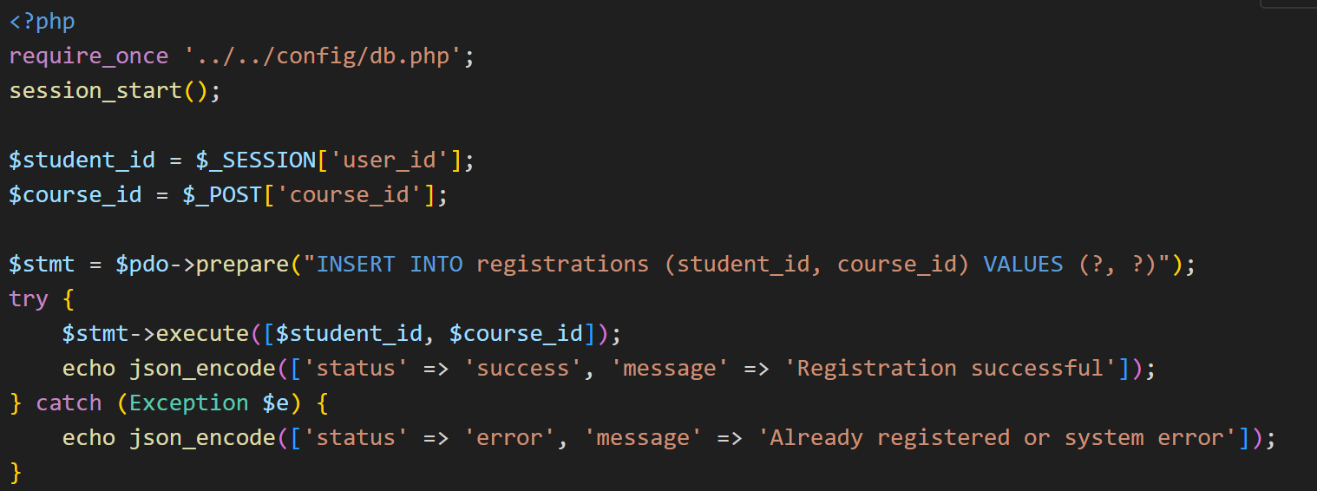
- Example Request/Response: Payment
Request
- URL: /modules/dangkyhocphan/thanhtoan_sv.php
- Method: POST
- Payload: { student_id, amount }
Response
- success: { status: "success", message: "Payment successful" }
- Fail: { status: "error", message: "Payment failed" }
Sample Code (thanhtoan_sv.php)
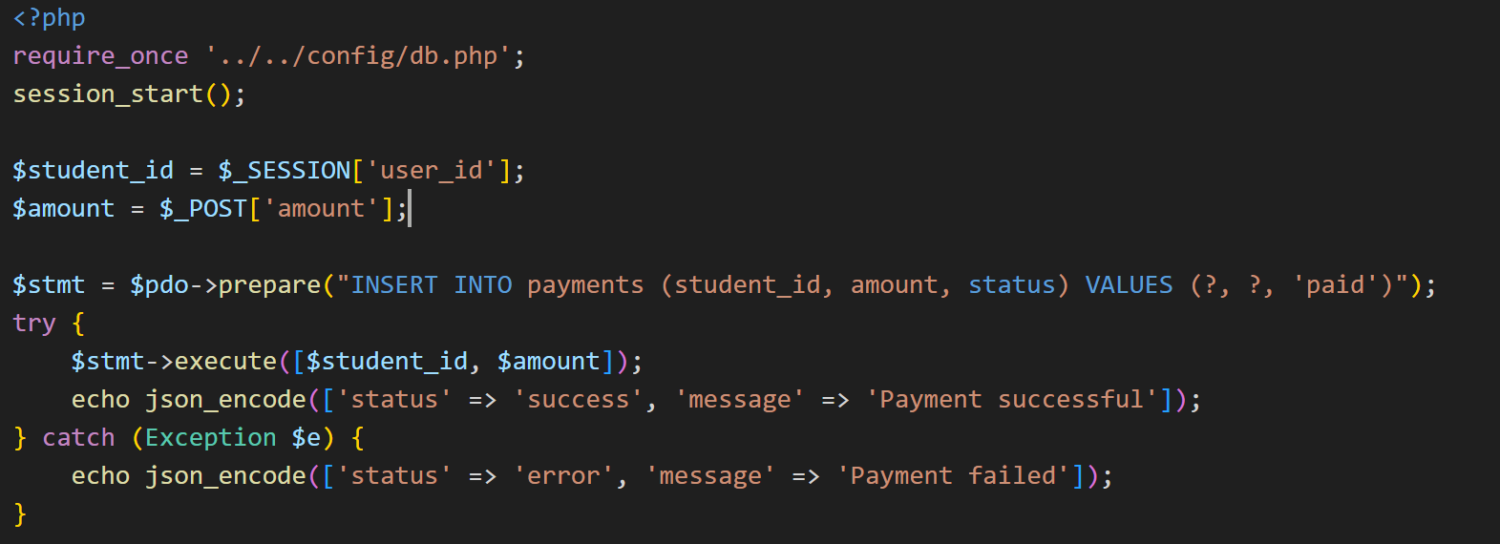
- Main Class Communication
- DB: Singleton or global $pdo from config/db.php.
- Business: Business logic functions in each module file.
- Presentation: Includes layout, renders data from BE.

Architecture Overview: Layered Monolith
- Classes
- Presentation Layer: User interface (HTML, PHP render, layout).
- Business Layer: Business processing (modules//.php).
- Data Access Layer: Connect, query DB (config/db.php).
- Database: MySQL (database.sql).
- Processing Flow
- Users operate on the interface (Presentation).
- The request is sent to BE, which handles the business (Business).
- BE querying and updating data (Data).
- The result returns the Presentation to display.

Detailed Architecture: Two Main Streams
- Stream 1: Book/view file (Course Registration)
- Students log in → dashboard_sv.php
- Choose modules → modules/dangkyhocphan/index_sv.php
- Press "Subscribe" → AJAX POST to save_registration.php
- 4. save_registration.php:
  - Check out the session, get student_id
  - Get course_id from POST
  - Call DB: INSERT to registrations
  - Return the resulting JSON
- FE receives response, displays notifications
Sequence Diagram (pseudo):
Students → FE (index_sv.php) → BE (save_registration.php) → DB← FE (notification)
- Stream 2: Payment
- Students go to the payment page → modules/dangkyhocphan/thanhtoan_sv.php
- Enter the amount, press "Pay" → AJAX POST to thanhtoan_sv.php
- thanhtoan_sv.php:
  - Check out the session, get student_id
  - Get the amount from POST
  - Call DB: INSERT into payments
  - Return the resulting JSON
- FE receives response, displays notifications
Sequence Diagram (pseudo):
Students → FE (thanhtoan_sv.php) → BE (thanhtoan_sv.php) → DB← FE (notification)

GLOSSARY
This section provides definitions for the terms and abbreviations used throughout this Software Architecture Document (SAD) to ensure consistency and clarity in communication between stakeholders regarding system components and functionalities.

USER ROLES & SYSTEM ACTORS
- System Administrator (Admin): Users with the highest level of privileges in the system, responsible for overall management and system configuration.
- Faculty / Lecturer: Users responsible for teaching academic modules. They have the authority to manage basic information for students within their assigned classes.
- Student / Learner: The primary users of the system, including all students currently enrolled in university training programs.
- University Staff: General staff members from various departments who have the permission to view the organizational structure or submit proposals for structural changes.
- Academic Affairs / Training Department Staff: Users responsible for managing academic operations, including the development and management of training programs (curricula), majors, courses, modules, and knowledge blocks.
- Administrative Staff: Users responsible for managing information related to the university's departments and organizational units.
- Finance / Accounting Staff: Users responsible for managing all financial matters related to student tuition fees and transaction reconciliation.

ACADEMIC & TRAINING PROGRAM TERMINOLOGY
- Training Program / Curriculum (CTDT): The complete framework of an academic major/course, including knowledge blocks, lists of modules, credits, learning outcomes, and the academic roadmap.
- Curriculum Framework: The standard and original version of a Training Program for each major, serving as the basis for implementing specific programs for each cohort.
- Knowledge Block: A collection of academic modules grouped by a specific theme or requirement within the curriculum (e.g., General Education, Fundamental, or Specialized Knowledge).
- Academic Module: A unit of knowledge with a defined volume measured in credits, usually a course or a part of a course, organized for teaching within a specific semester.
- Credit: A unit of measurement for the workload of an academic module.
- Learning Outcomes: The specific requirements of knowledge, skills, and competencies that learners must achieve upon completion of a training program.

USE CASE & PROJECT MANAGEMENT TERMINOLOGY
- Use Case: A description of how a user interacts with the system to achieve a specific goal, including the sequence of actions and system responses.
- Use Case ID (UC-X. Y): A unique identifier for a specific Use Case within the document.
- Basic Flow (Normal Flow): The primary and most common successful scenario of a Use Case, describing the steps taken by the user and the system to achieve the goal.
- Alternative Flows: Secondary scenarios within a Use Case describing other possible paths or actions taken to achieve the goal outside the basic flow.
- Exceptions (Exception Flows): Scenarios or error situations that occur during a Use Case, along with how the system responds and handles them.
- Trigger: An initial event or action performed by a user or the system that initiates a Use Case.
- Preconditions (PRE-X): Conditions that must be satisfied (or must be true) before a Use Case or a specific action can begin.
- Post-conditions (POST-X): The observable state of the system after a Use Case or an action has been successfully completed.
- Priority: The level of importance of a Use Case or requirement, typically categorized as High, Medium, or Low.
- Frequency of Use: How often a Use Case or function is executed by users.
- Business Rules (BR-X. Y): Constraints or logical rules that govern the operation of the system, numbered according to the related Use Case.
- Assumptions: Factors considered to be true or expected to happen in the future without proof, which influence the project or system.
- Proposal / Request: A formal request for change (e.g., changing the organizational structure) created and submitted for approval by an authorized person.
- Proposal ID: A unique identifier for a change proposal within the system.
- Other Information: A supplementary section containing requirements or notes that do not fall into other primary Use Case categories.

TECHNOLOGY, SECURITY & SYSTEMS TERMINOLOGY
- Database/Database: A structured, organized collection of data to efficiently store, manage, and retrieve information.
- API (Application Programming Interface): A set of definitions that allow software components to communicate with each other. Covered in the context of payment gateway integration.
- Password: A secret string of characters used to authenticate a user's identity when accessing a system.
- OTP (One-Time Password): A one-time password for identity or transaction authentication, usually sent via email or SMS.
- RBAC (Role-Based Access Control): A method of restricting a user's access based on the role assigned to them in the system.
- PCI DSS (Payment Card Industry Data Security Standard): A set of security standards for organizations that handle payment card information.
- Log/Log: A record of activities or events that occur in the system, used for auditing, tracing, and reporting.
- Responsive Design: A web interface design approach that allows layouts and content to automatically adjust to display well on multiple screen sizes and devices (desktop, tablet, mobile).
- Form: A data entry interface on the system where users fill in data fields. (Synonymous with "form" in the document).
- PDF (Portable Document Format): A file format for reliably presenting and exchanging documents, regardless of software, hardware, or operating system.

IDENTIFIERS
- Faculty Code: A unique identifier for a department in the school.
- Key Code: A unique identifier for a course (e.g., Class of 2023, Key K17).
- Industry code: A unique identifier for a training discipline.
- Module Code: The unique identifier for a module.
- Department Code: A unique identifier for a department in the school.

PROJECT DOCUMENTS
- Software Architecture Document (SAD): A document that provides a comprehensive architectural overview of the system, detailing significant design decisions, structural patterns, and technical frameworks. This is the current document.

USE CASE SPECIFICATION (FUNCTIONAL REQUIREMENTS)

List of Use Cases

Overall Use Case
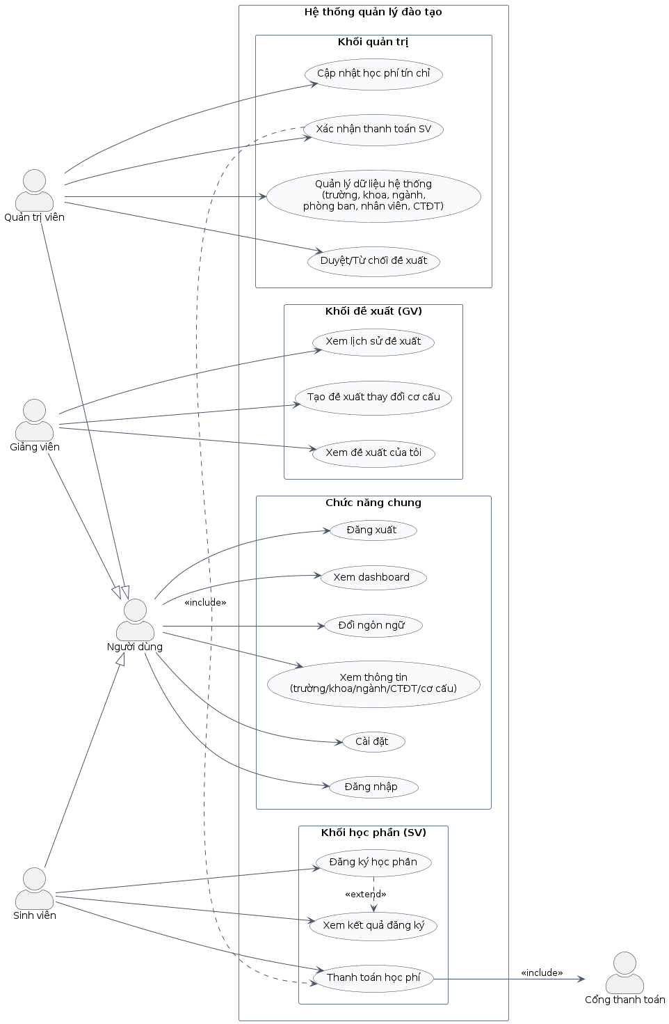

UC1 Team – Organizational Structure Management:
- UC-1.1: School Management
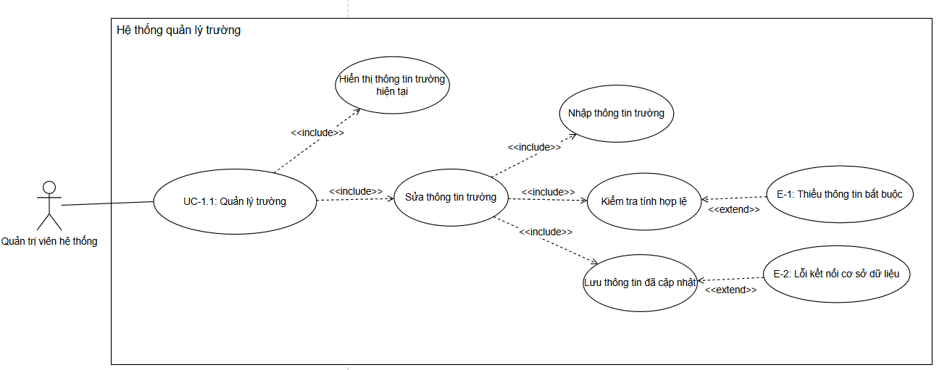
- UC-1.2: Faculty Management
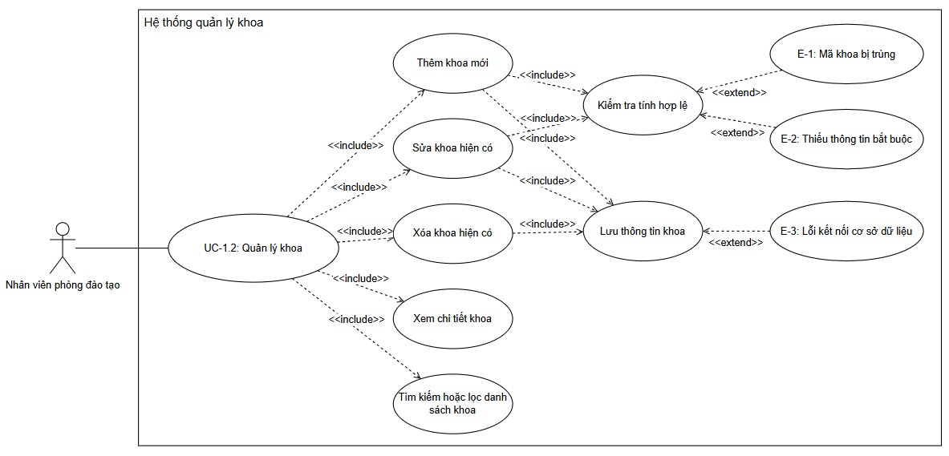
- UC-1.3: Department Management
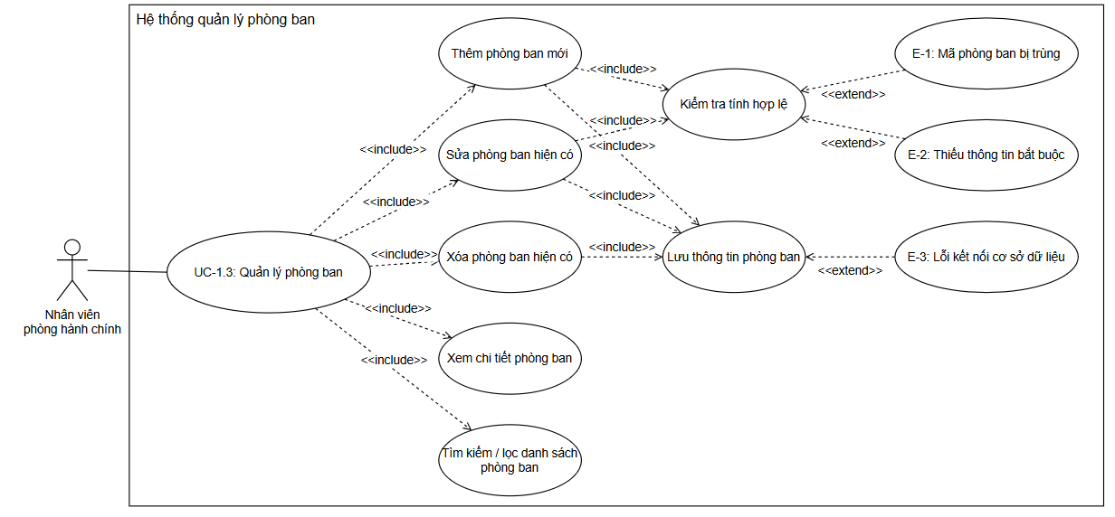
- UC-1.4: Accepting/Rejecting Proposals
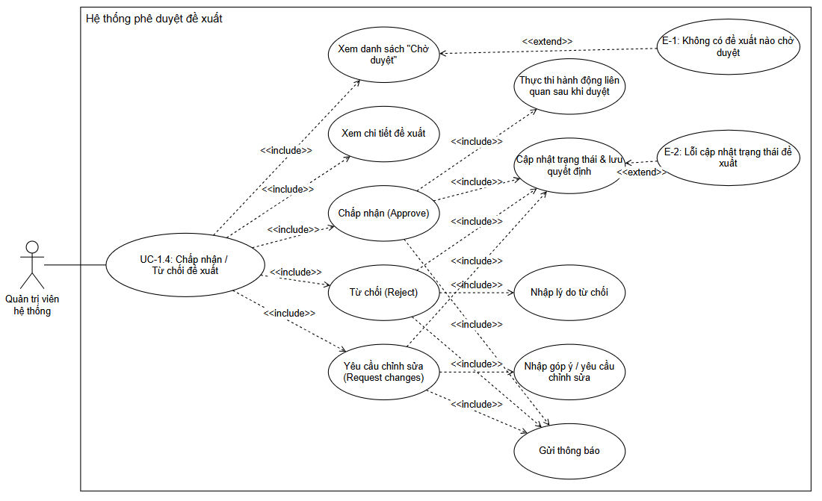
- UC-1.5: Displaying the Organizational Structure
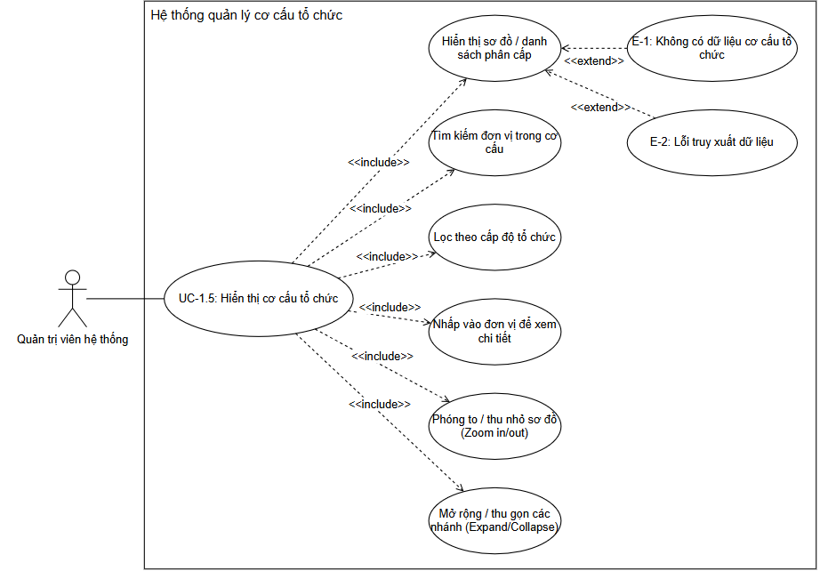
- UC-1.6: Organizational Structure Change Proposal
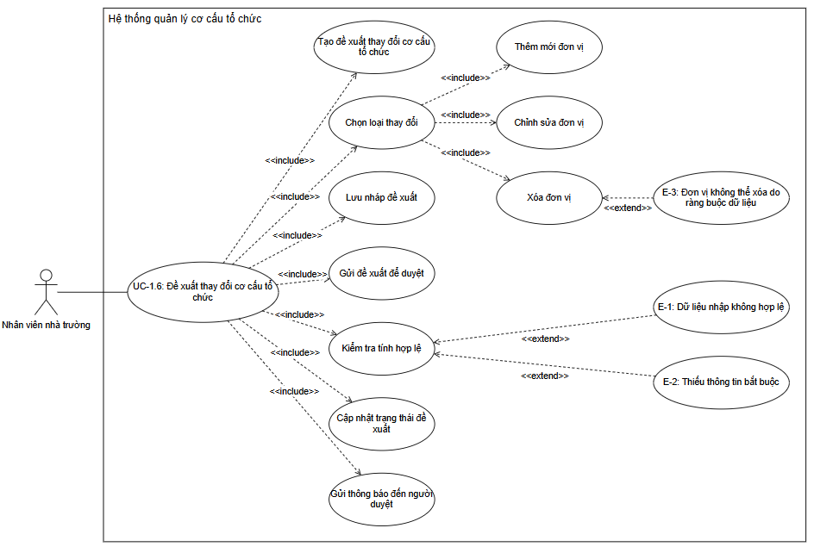
- UC-1.7: View Organizational Structure Display
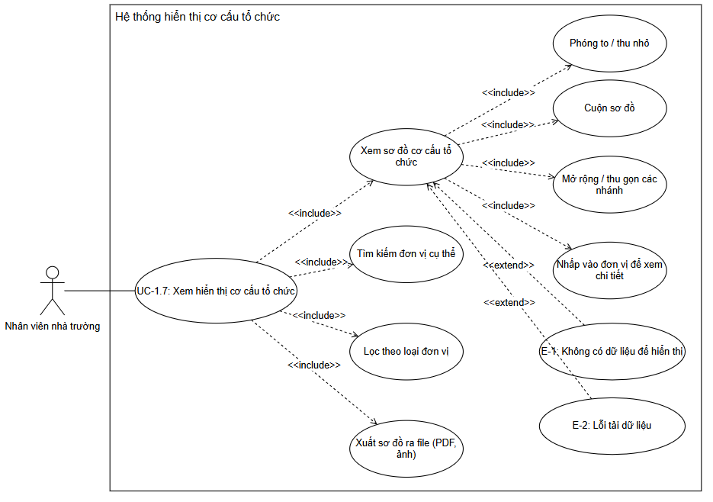

UC2 Team – User Management:
- UC-2.1: User Administration
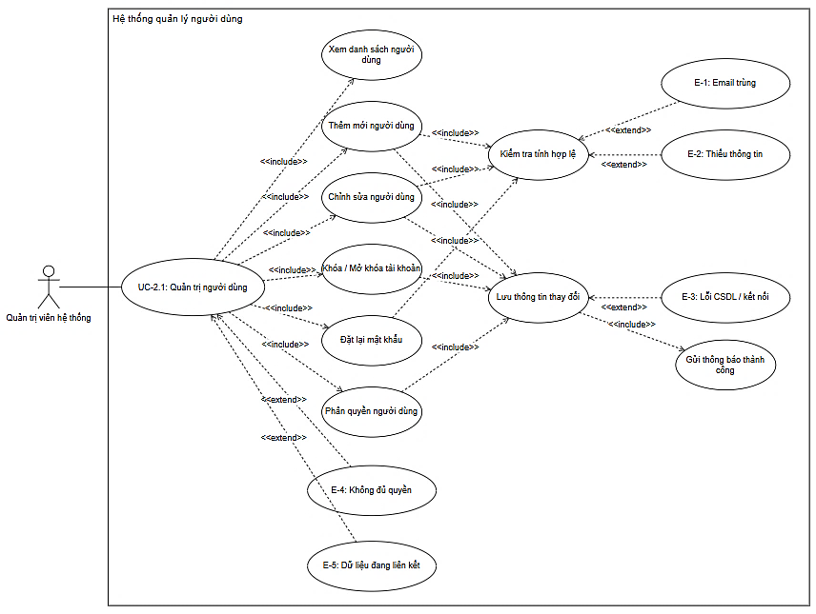
- UC-2.2: Student Management
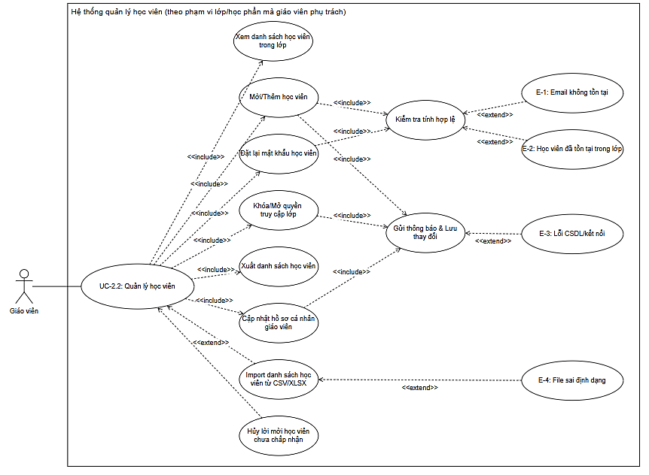
- UC-2.3: Account Management & Class Participation (Students)
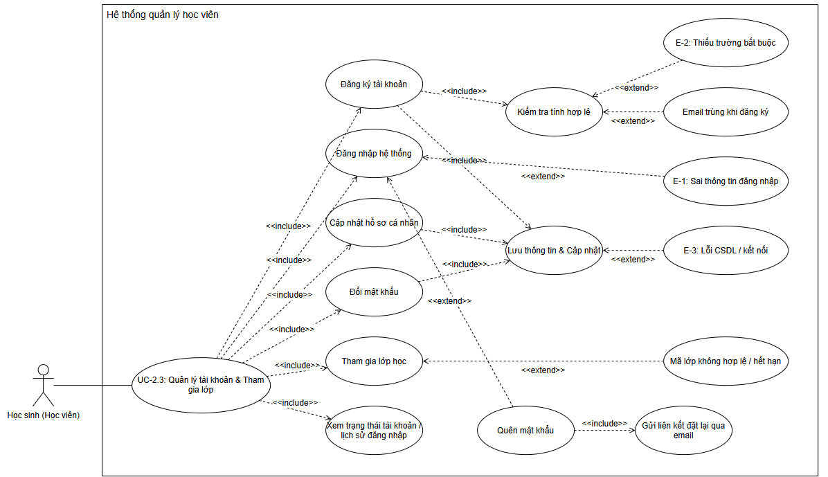

UC3 Group – Developing Training Programs (CTs):
- UC-3.1: Course Management
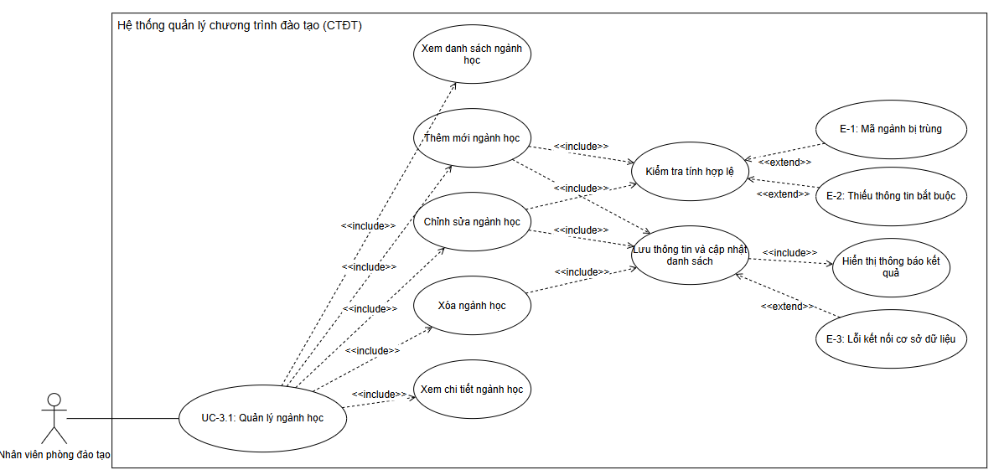
- UC-3.2: Course Management
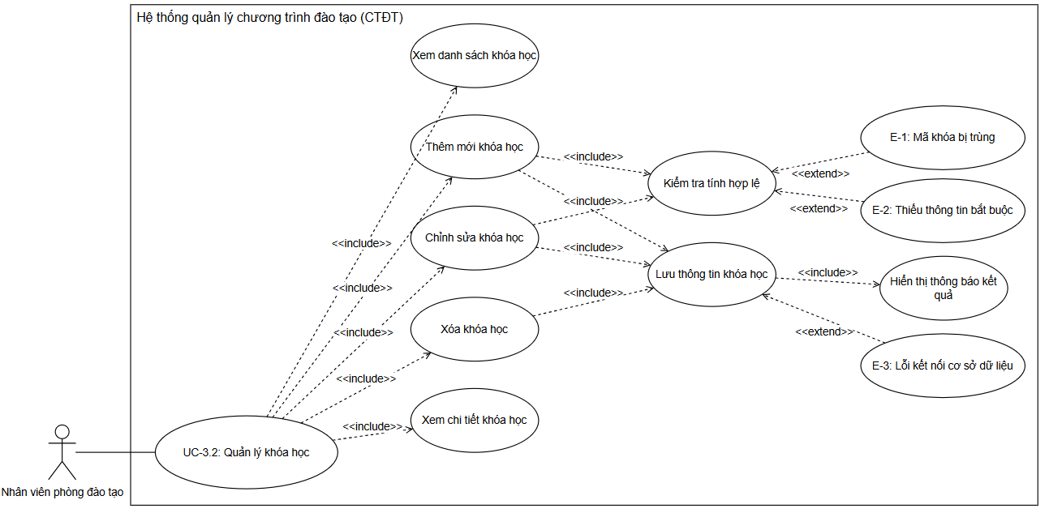
- UC-3.3: Module Management
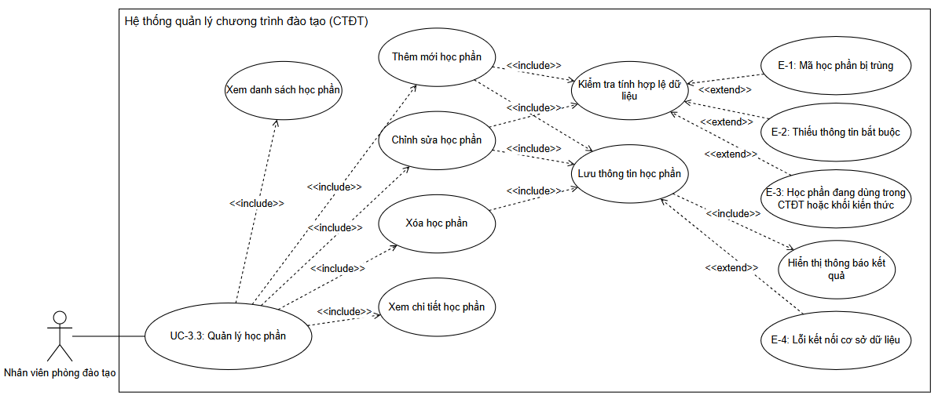
- UC-3.4: Knowledge Block Management
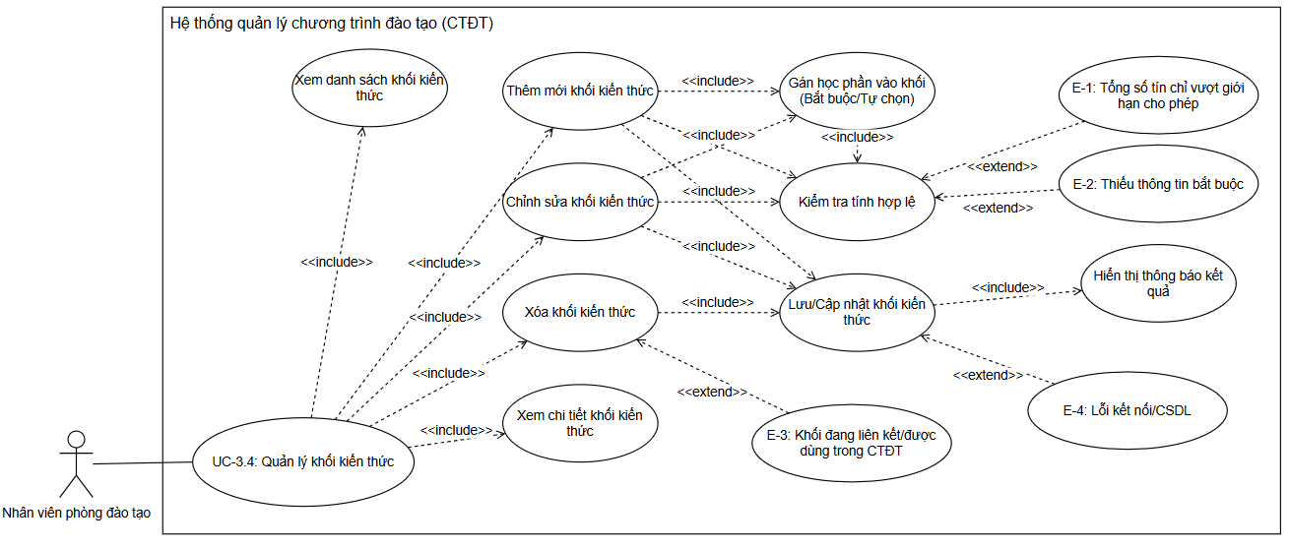
- UC-3.5: Curriculum Structure Management
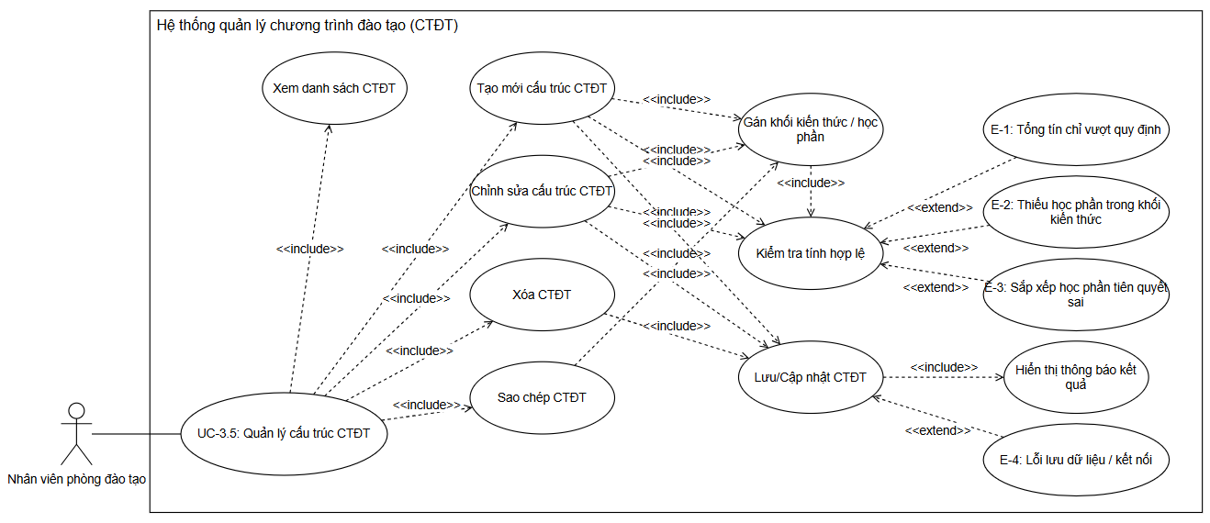
- UC-3.6: Developing a curriculum framework
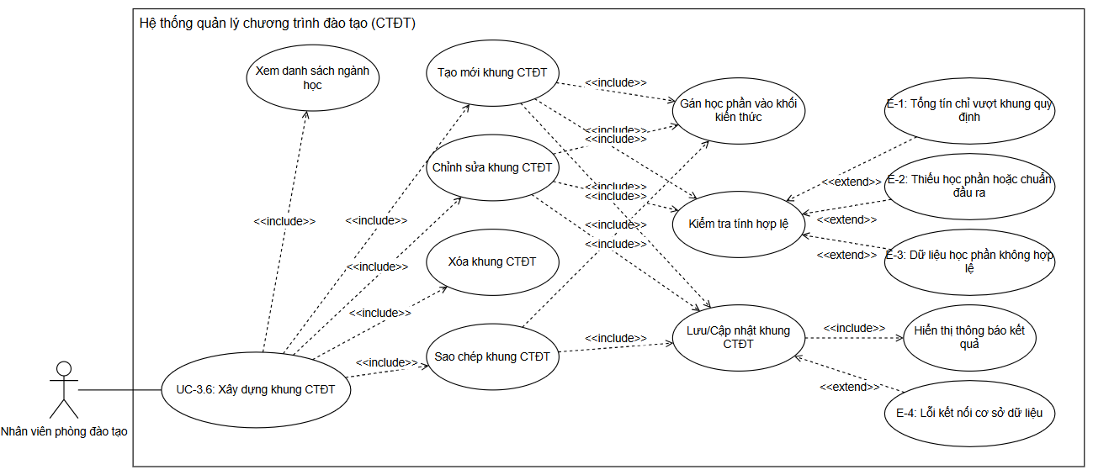
- UC-3.7: Curriculum Display
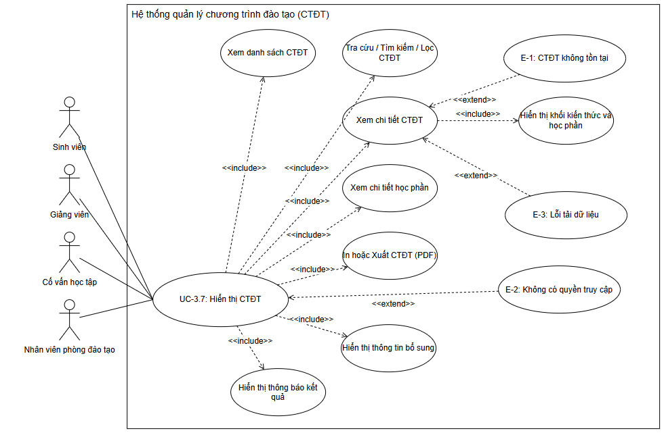

UC4 Group – Tuition Calculation:
- UC-4.1: Tuition Calculation
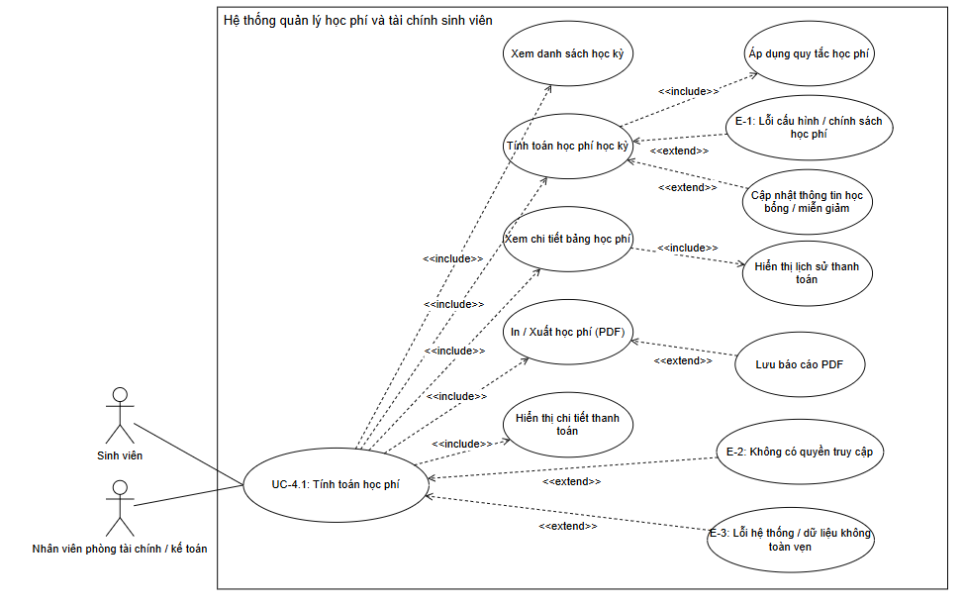
- UC-4.2: Online Tuition Payment
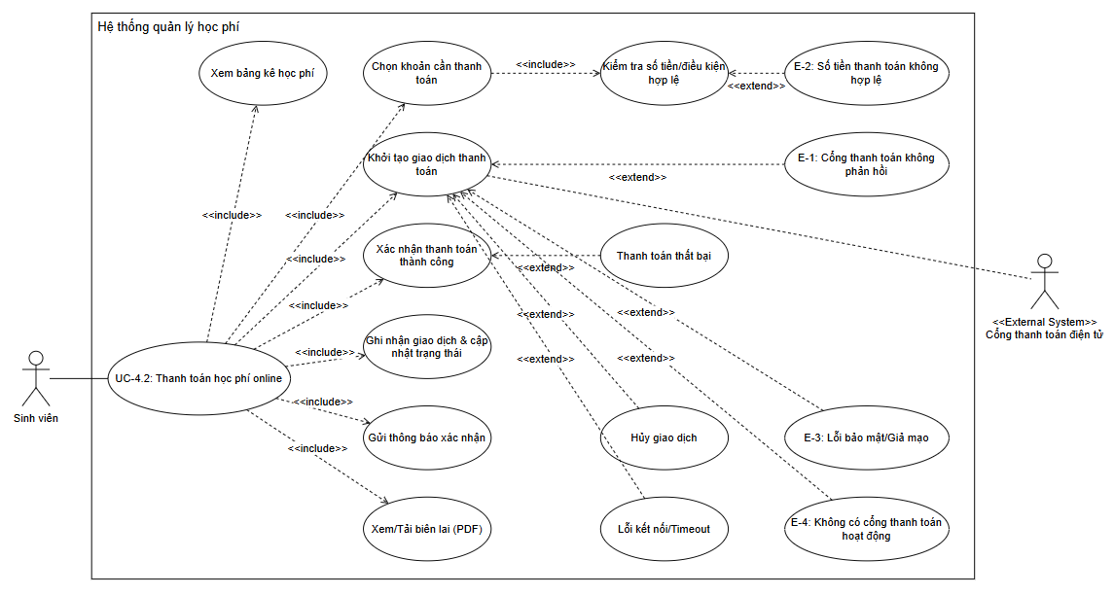

UC1 Group Interface Specification and Construction – Organizational Structure Management
ID and Name | UC-1.1: School Management
Created by | Group 13
Primary Actor | System Administrator
Description | System administrators access the system to manage and update general school information, including: school name, address, contact information, logo, and other basic information.
Trigger | The system administrator selects the "Field Management" function in the system interface.
Preconditions | PRE-1: The system administrator is logged into the system.  PRE-2: The administrator account has access to the "School Management" function.
Postconditions | POST-1: The field information is successfully updated in the database.
Normal Flow | - The administrator selects the "Manage Schools" function.  - The system displays the current general information of the school.  - Admins select the "Edit" action.  - The system displays a form to edit field information.  - The administrator enters the information to be changed: school name, address, phone number, email, website, logo (if applicable).  - Validity check system: the required fields have been entered in full.  - The system saves the updated field information.  - The system displays a success message and returns to the screen displaying the updated field information.
Alternative Flows | Edit existing field information  1. The administrator selects the "Edit" operation from the field information display screen (step 2 of the main stream).  2. The system displays the form to edit the field information.  3. The administrator enters the information to be changed: school name, address, phone number, email, website, logo (if any).  4. Validity check system: the required fields have been fully entered.  5. The school information saving system has been updated.  6. The system displays a success message and returns to the updated field information display screen.
Exceptions | E-1 Missing required information:  - The system displays a message asking for complete information.  - Go back to step 3 of alternate flow 1.1.  E-2 Database Connection Error:  - The system displays the message: "Unable to save data. Please try again later."  - Pause process.
Priority | High
Frequency of Use | Occasionally
Business Rules | BR-1: The name of the school must not be blank.  BR-2: The school address must not be vacant.
Other Information | Editing operations are recorded in logs for inspection and reporting.
Assumptions | - The field information data already exists in the system.  - The user has administrative rights.

ID and Name | UC-1.2: Faculty Management
Created by | Group 13
Primary Actor | Training Department Staff
Description | Training department staff access the system to manage the list of faculties, including: adding new ones, editing, deleting, and viewing faculty details.  Information about each department includes: faculty code, faculty name, contact information, dean.
Trigger | The employee selects the "Course Management" function in the system interface.
Preconditions | PRE-1: The employee is logged into the system.  PRE-2: Staff accounts with access to the "Faculty Management" function.
Postconditions | POST-1: Faculty information is successfully added, edited, or deleted in the database.  POST-2: The faculty list is updated and displayed again on the management interface.
Normal Flow | Managing a faculty  1. Staff select the "Faculty Management" function.  2. The system displays a list of available faculties.  3. The employee selects one of the operations: Add New, Edit, Delete, or View Details.  4. If you select "Add New:  -The system displays the form to enter faculty information.  -Staff enter: faculty code, faculty name, contact information, dean (if any).  5. Validity Inspection System:  -The department code is not duplicated.  -The required fields have been entered in full.  6. The system saves information about new faculties or updates existing faculties.  7. The system displays a success message and returns to the updated faculty list.
Alternative Flows | 1.1 Fix an existing faculty  1. The staff selects the department to be corrected.  2. Faculty details display system.  3. Staff edit information and confirm.  4. Return to step 5 of the main thread (validity check).  1.2 Delete an existing lock  1. The staff selects the department to be deleted.  2. The system requires action confirmation.  3. If agreed, the data binding inspection system (the faculty has a major or affiliated lecturer will not be able to delete it).  4. If valid, the system deletes and returns to step 7 of the main thread (successful notification).
Exceptions | E-1 Duplicate Faculty Code  - The system displays an error message: "The faculty code already exists."  - The employee re-enters the information and returns to step 4.  E-2 Missing required information  - The system displays a message asking for complete information.  - Go back to step 4.  E-3 Database Connection Error  - The system displays the message: "Unable to save data. Please try again later."  - Pause process
Priority | High
Frequency of Use | Frequent — an average of 2–5 times a day.
Business Rules | BR-1: The faculty code is unique throughout the system.  BR-2: The name of the department must not be left blank.  BR-3: Faculty affiliated with a discipline, faculty, or training program cannot be deleted.
Other Information | - Staff can search for departments by code, name, or dean.  - All operations are recorded in logs for inspection and reporting.
Assumptions | Lecturer data already exists in the system.

ID and Name | UC-1.3: Department Management
Created by | Group 13
Primary Actor | Administrative Staff
Description | Administrative staff access the system to manage the list of departments (e.g., Training Department, Finance Department, Student Affairs Department, etc.), including: adding, editing, deleting, and viewing department information details.  Information about each department includes: department code, department name, contact information, department head.
Trigger | The employee selects the "Department Management" function in the system interface.
Preconditions | PRE-1: The employee is logged into the system.  PRE-2: Employee accounts with access to the "Department Management" function.
Postconditions | POST-1: Department information is successfully added, edited, or deleted in the database.  POST-2: The list of departments is updated and displayed again on the management interface.
Normal Flow | Manage a department  1. Employees select the "Department Management" function.  2. The system displays a list of available departments.  3. The employee selects one of the operations: Add New, Edit, Delete, or View Details.  4. If you select "Add New":  - The system displays the form for entering department information.  - Staff enter: department code, department name, contact information, department head (if any).  5. Validity Inspection System:  - The department code is not duplicated.  - The required fields have been entered in full.  6. The system saves information about new departments or updates existing departments.  7. The system displays a success message and returns to the updated department list.
Alternative Flows | 1.1 Fix an existing department  1. The employee selects the department to be corrected.  2. The system displays department details.  3. Staff edit information and confirm.  4. Return to step 5 of the main thread (validity check).  1.2 Delete an existing department  1. The employee selects the department to be deleted.  2. The system requires action confirmation.  3. If agreed, the system checks the data binding (the department that has employees or the associated function cannot be deleted).  4. If valid, the system deletes and returns to step 7 of the main thread (successful notification).
Exceptions | E-1 Duplicate Department Code  - The system displays an error message: "The department code already exists."  - The employee re-enters the information and returns to step 4.  E-2 Missing required information  - The system displays a message asking for complete information.  -Return to step 4.  E-3 Database Connection Error  - The system displays the message: "Unable to save data. Please try again later."  - Pause process.
Priority | High
Frequency of Use | Frequent — an average of 2–5 times a day.
Business Rules | BR-1: The department code is unique throughout the system.  BR-2: The name of the department must not be left blank.  BR-3: The department associated with an employee or other management function cannot be deleted.
Other Information | - Employees can search for departments by code, name, or department head.  - All operations are recorded in logs for inspection and reporting.
Assumptions | -Employee data (to select department heads) already exists in the system.

ID and Name | UC-1.4: Accepting/Rejecting Proposals
Created by | Group 13
Primary Actor | System Administrator
Description | Proposal reviewers access the system to view a list of pending proposals, view each proposal in detail, and accept or reject the proposal.
Trigger | The browser suggests to select the "Browse Suggestions" function in the system interface.
Preconditions | PRE-1: The person reviewing the proposal is logged into the system.  PRE-2: The browser account has access to the "Browse Suggestions" function.  PRE-3: There is at least one proposal that is in the "Pending Review" status.
Postconditions | POST-1: The status of the proposal is updated to "Approved" or "Declined" in the database.  POST-2: The data related to the proposal (if accepted) is automatically updated or new to the system (e.g., new discipline is added).  POST-3: Notification of the approval/rejection decision is sent to the creator of the proposal.
Normal Flow | Browse a proposal  - The Recommendation Reviewer selects the "Browse Proposals" function.  - The system displays a list of pending proposals, including summary information (e.g., proposal ID, proposal name, sender, submission date).  - Recommendation reviewers select a specific proposal to view the details.  - The system displays all the details of the proposal.  - The reviewer suggests choosing one of the actions: "Accept" or "Decline".  - If you select "Decline":  - The system asks the reviewer to enter the reason for the rejection.  - The reviewer enters the reason for the rejection.  - The reviewer of the proposal confirms his decision.  - The system updates the status of the proposal in the database and takes the necessary actions (e.g., creating a new discipline if the proposal is approved).  - The system displays a success message and sends a notification of the decision to the creator of the proposal.  - The system returns to the list of pending proposals (or approved/rejected lists).
Alternative Flows | Request a proposed edit  - At step 5 of the main stream, the reviewer selects "Request Editing".  - The system asks to enter comments/reasons for editing.  - The reviewer enters the comment and confirmation information.  - The proposal status is updated to "Edit requested" and a notification with feedback is sent to the creator of the proposal.  - The system returns to the list of suggestions.
Exceptions | E-1 No proposals pending approval  - The system displays the message: "There are currently no proposals pending approval."  - The process is over.  E-2 Suggested Status Update Error  - The system displays the message: "The suggested status cannot be updated. Please try again later."  - Pause process.
Business Rules | BR-1: Each proposal can only be approved or rejected once.  BR-2: The reason for rejection is required if "Decline" is selected.  BR-3: If the proposal is accepted, the relevant information must be automatically integrated into the respective management modules (e.g., course management, course management).
Other Information | - All approval/rejection/edit requests are logged for inspection and reporting.  - Notifications can be sent via email or internal system notifications.
Assumptions | - The mechanism for creating and sending proposals already exists and works stably.  - User data (including roles and permissions) is tightly managed.

ID and Name | UC-1.5: Displaying the Organizational Structure
Created by | Group 13
Primary Actor | System Administrator
Description | Users access the system to view the hierarchy of the organization (e.g., faculties, departments, disciplines) in the form of a chart or hierarchical list.
Trigger | The user selects the 'Organizational Structure' or 'Organizational Chart' function in the system interface.
Preconditions | PRE-1: The user is logged into the system.  PRE-2: Data on the organizational structure (faculty, department, discipline) has been configured and stored in the system.
Postconditions | (There is no specific postcondition as this is a function that displays information).
Normal Flow | View organizational structure  - The user selects the "Organizational structure" function.  - The system queries data about organizational units (Faculties, Departments, Disciplines, etc.) and their hierarchical relationships.  - The system displays a diagram or hierarchical list of the organizational structure.  - (Optional) Users can interact with diagrams/lists:  - Zoom in/out.  - Expand/collapse nodes.  - Click on a unit to view details (e.g., information about Faculty X).  - (Optional) Users can use the search or filter function to quickly locate a specific unit in the structure.
Alternative Flows | 1.1 Searching for units in the structure  - At step 4 of the main stream, the user enters the keyword in the search box.  - The system displays units that match the entered keywords.  1.2 Filter by organizational level  - At step 4 of the main stream, the user selects a filtering criterion (e.g., only show Faculty, only Show Subject).  - The system displays the organizational structure that has been filtered by criteria.
Exceptions | E-1 No Organizational Structure Data  - The system displays the message: "No organizational structure data to display. Please contact the administrator."  - The process is over.  E-2 Data Retrieval Errors  - The system displays the message: "An error occurred when retrieving organizational structure data. Please try again later."  - Pause process.
Business Rules | BR-1: Each organizational unit (except the top level) must have a single parent unit.  BR-2: The hierarchy must not have a loop (e.g., Department A is a child of Department B, Department B is a child of Department A).  BR-3: The information displayed must be consistent with the data that manages the organizational units.
Other Information | - The organizational structure can include multiple levels (e.g., School, Faculty, Department, Discipline, Specialization).  - This function can link with other functions to provide more detailed information about each unit when the user clicks.
Assumptions | - The organizational structure can include multiple levels (e.g., School, Faculty, Department, Discipline, Specialization).  - This function can link with other functions to provide more detailed information about each unit when the user clicks.

ID and Name | UC-1.6: Organizational Structure Change Proposal
Created by | Group 13
Primary Actor | School Staff
Description | The manager or unit head accesses the system to create and submit proposals for changes to the organizational structure (adding, editing, deleting units).
Trigger | The user selects the 'Suggest Organizational Structure Changes' function in the system interface.
Preconditions | PRE-1: The user is logged into the system.  PRE-2: The user account has access to the "Propose Changes to Organizational Structure" function.
Postconditions | POST-1: Organizational structure change proposal is successfully created and saved to the database with the status of "Pending approval".  POST-2: Notice of new proposal sent to the authorized reviewer.
Normal Flow | Create a proposal to change the organizational structure  - The user selects the "Suggest changes to the organizational structure" function.  - The system displays a proposal creation form.  - The user selects the type of change: "Add New Unit", "Edit Unit", or "Delete Unit".  - If you select "Add New Unit":  The system asks to enter the details of the new unit (e.g., unit name, unit ID, parent unit, description).  5 . If you select "Edit Unit":  - system displays a list of available units.  - The user selects the unit to be edited.  - The system displays the current information of the unit.  - The user edits the necessary information.  6.If select "Delete Unit":  - The system displays a list of available units.  - The user selects the unit to be deleted.  - The system warns of constraints (e.g., units with subunits, personnel).  7. The user enters the reason/explanation for the change proposal.  8.The system checks the validity of the input data (e.g., the unit code is not duplicated when adding a new one, the required fields have been entered).  9.The user confirms the submission of the proposal.  10.The system saves the proposal to the database with the status of "Pending approval" and sends a notification to the reviewer.  11.The system displays the success message and returns to the suggestion management screen.
Alternative Flows | - Save proposal drafts  - At step 9 of the main stream, the user selects "Save Draft" instead of "Submit Proposal".  - The system saves proposals with a status of "Draft" without sending them for approval.  - Users can come back to edit and submit later.  - Review submitted proposals  - The user selects the "Manage My Suggestions" function.  - The system displays a list of submitted proposals and their status.
Exceptions | E-1 Invalid Data  - The system displays the error message: "The input data is invalid. Please check again."  - The user enters the information again and returns to step 8.  E-2 Missing required information  - The system displays the message: "Please enter all required fields."  - The user enters the information again and returns to step 8.  E-3 Units that cannot be removed due to binding  - In step 6, if the unit has constraints that do not allow deletion (for example, there is a sub-unit, there are personnel who are affiliated), the system displays the message: "This unit cannot be deleted due to data constraints. Please resolve the constraint before deleting."  - Pause deletion process.
Business Rules | BR-1: Each proposal must have a unique code and a creator.  BR-2: Basic unit information fields (code, name) are required.  BR-3: It is not possible to add new units with codes that are identical to existing units or units that are in a pending proposal.  BR-4: The unit cannot be deleted if there are subordinate units or personnel (unless there is a related move/deletion procedure).
Other Information | - Proposals can be accompanied by attachments (e.g., decisions, drawings of a new org chart).  - All suggested changes and their status are logged.
Assumptions | - The basic organizational unit management mechanism already exists in the system.  - There is a separate proposal review flow (which may relate to UC-1.4: Accept/Reject proposals).

ID and Name | UC-1.7: View Organizational Structure Display
Created by | Group 13
Primary Actor | School Staff
Description | Users access the system to view the official and approved organizational structure of the entire school or unit.
Trigger | The user selects the 'Org Chart' or 'Field Structure' function in the system interface.
Preconditions | PRE-1: The user is logged into the system (or is a public user if the function is public).  PRE-2: Data on the organizational structure has been updated and approved in the system.
Postconditions | (There is no specific postcondition as this is a function that displays information).
Normal Flow | View the organizational structure chart  - The user selects the "Org Chart" function.  - Current organizational structure data query system (approved and applied).  - The system displays the organizational structure as a visualization (e.g., tree diagram, organizational chart) or hierarchical list.  - Users can perform operations to navigate and explore:  - Zoom in/out: To see an overview or details of each part of the diagram.  - Scroll: To move through sections of the large diagram.  - Expand/Collapse: To show or hide the child units of a parent unit.  - Click the unit: To see a summary of the unit (example: name, key function, head).  - (Optional) Users can print or export diagrams in popular formats (PDF, photos).
Alternative Flows | - Searching for specific units  - At step 4 of the main stream, the user enters the name or unit code in the search box.  - The system highlights or directly displays the unit found in the diagram.  - Filter by unit type  - At step 4 of the main stream, the user selects a filtering criterion (e.g., only show Faculty, only Show Subject).  - The adjustment system displays the diagram with only units that match the criteria.
Exceptions | E-1 No data to display  - The system displays the message: "The organizational structure is being updated or there is no data to display."  - The process is over.  E-2 Data Load Errors  - The system displays the message: "Unable to load organizational structure data. Please try again later."  - Pause process.
Business Rules | BR-1: The display diagram must properly reflect the approved and active organizational structure.  BR-2: The displayed information must be consistent with the organizational unit management data.
Other Information | - This functionality is designed to provide an overview and easy to understand of the organizational structure for every user with access.  - Links to more detailed information about each unit can be integrated (e.g. department website, personnel directory).
Assumptions | - Organizational structure data is maintained and updated through other management functions (e.g., after a proposed change is accepted).  - The system is capable of visualizing hierarchical data structures effectively.

UC2 Group Interface Specification and Construction – User Management
ID and Name : | UC-2.1: User Administration
Creat by: | Group 13
Primary Actor: | System Administrator
Description: | Allows system administrators to manage system-wide users: add new, edit, lock/unlock, delete, reset passwords, and assign/revoke roles, to ensure access control and security.
Trigger: | Admin selects the "User Management" function in the admin interface.
Preconditions: | PRE-1: The system administrator has successfully logged in to the system.  PRE-2: The Administrator account must have defined roles and permissions to access and perform user management operations.
Postconditions: | POST-1: User records created/updated/deleted  success in databases.  POST-2: The list of refreshed users is displayed.
Normal Flow: | - Open "User Management".  - The system displays the list (search, filtering by role/status, pagination).  - Admin selects the operation: Add New / Edit / Lock–Unlock / Delete / Decentralize / Reset Password.  - If Add New: open the form (Full Name, Email, Password, Role, Status, Phone).  - Validity check: unique email, password ≥ 6 characters, enough required fields.  - Save your changes.  - Message "Success" and return to the list.
Alternative Flows: | 1.1 Edit: select the user → view the details → update → → to step 7.1.2 Lock/Unlock: select the account → confirm → update the → status to step 7.1.3 Delete: select the user → confirm → if there is still a data link, block; if it is valid, delete the → to step 7.1.4 Decentralization: open the decentralization pane → assign/revoke roles → save → update the corresponding rows.1.5 Reset password: confirm the operation → the system creates a temporary password/send a reset email.
Exceptions: | E-1 Duplicate Email  Say "The email already exists." → go back to step 4.  E-2 Missing Information  Say "Please enter all the information." → go back to step 4.  E-3 DBL/Connection Error  Says "Unable to save data. Please try again later."  E-4 Insufficient Permissions  Says "You don't have permission to do this."  E-5 Linking Data  Says "Unable to delete due to data linking."
Priority: | High
Frequency of Use: | 3–10 times/day per Admin
Business Rules: | BR-1: Email is unique.  BR-2: Passwords must be encrypted when saved.  BR-3: Unable to delete users who still link data.  BR-4: All CRUD/role/reset password operations are logged.  BR-5: RBAC decentralization, server-side check.
Other Information: | Search by first name/email/role; export Excel by filter; confirmation warning when locking/deleting; Displays the account's most recent history (optional).
Assumptions: | RBAC already exists; periodic backup system; OTP/reset email channel works.

ID and Name : | UC-2.2: Student Management
Creat by: | Group 13
Primary Actor: | Teachers
Description: | Allow teachers to manage accounts within the class/module under their charge: invite/admit students to the class, view students' basic profiles, reset passwords for students in class, lock/unlock class access (do not delete system accounts), and update teachers' personal profiles.
Trigger: | The teacher opens "My Class" → "Student Management" or opens "Personal Profile".
Preconditions: | PRE-1: The teacher is logged in.  PRE-2: Assigned to be in charge of the corresponding class/module.
Postconditions: | POST-1: The list of students in the class is updated.  POST-2: Changes to students/classes are effective within the class.  POST-3: Teacher's personal profile is updated.
Normal Flow: | - Open the "Student Management" of a class.  - The system displays the list of students (name, email, class status, date of participation).  - Teacher selects actions: Invite/Add students (via email/class code), Reset student password , Lock–Open student class access, Export list.  - If Invite/Add: enter an email or download a list file → the system sends the invitation/enrollment to the class.  - If Reset Password: confirm → system to create a reset process (email link or temporary password).  - If Lock–Open: confirm → update the within-class access status.  - Announce "Success" and refresh the list.
Alternative Flows: | 1.1 Import lists: download sample files → upload CSV/XLSX files → preview → confirm bulk enrollment.  1.2 Cancellation: if the student has not accepted the invitation → canceled successfully.  1.3 Update the Teacher's personal profile: go to "Personal Profile" → edit the → saved.
Exceptions: | E-1 : The email does not exist in the system at the time of registration: displays "Send an invitation to register before enrolling".  E-2 : Not within the scope of the class: "You have no authority to manipulate this student."  E-3 : DB/Connection Error: Operation failed; error message displayed.  E-4 –: File entered in the wrong format: error reported line/column details.
Priority: | High
Frequency of Use: | Regular according to class schedule (daily/weekly)
Business Rules: | BR-1: Teachers do not have the right to delete students' system accounts.  BR-2: Teachers only operate within the scope of the class under their charge.  BR-3: Password reset is done via the official mechanism (email/OTP); does not display the existing password.  BR-4: All enrollment/lock-on/reset operations are logged.
Other Information: | The interface has search, filtering by status in the class; support for exporting student lists; instructions for recovering accounts for students.
Assumptions: | The class/module has been created and assigned the correct permissions; Active email to send invite/reset.

ID and Name : | UC-2.3: Account Management & Class Participation (Students)
Creat by: | Group 13
Primary Actor: | Student (Student)
Description: | Allow students to manage personal accounts: register, log in, update profiles, change passwords; join the class using the class code/invitation; View your account status and basic login history.
Trigger: | Students select "Register/Login", "Personal Profile", or "Join Class".
Preconditions: | PRE-1: The system is operational.  PRE-2: Students access the correct website/application address.
Postconditions: | POST-1: Account created/validated/updated successfully.  POST-2: Successful class enrollment if the code/invitation is valid.
Normal Flow: | - If you don't have an account yet→ select Sign up: enter your Full Name, Email, Password, Password Confirmation, → validity check → create an account → receive a verification email (if enabled).  - If you already have an account→ Log in with Email + Password.  - Open Personal Profile to update (Full Name, Profile Picture, Phone) or Change Password.  - Select Join Class → enter the class code or accept the invitation → the enrollment system.  - The system displays notifications and updates the interface.
Alternative Flows: | 3.1 Forgot password: select "Forgot password?" → enter your email → the system sends a reset link. 3.2 Duplicate email when registering: display "Email already exists." 3.3 Invalid/expired class code: report an error and instructions to contact the Teacher.
Exceptions: | E-1 Wrong Credentials  - Displays a generic error message.  E-2 Missing Required Schools  - Re-entry requests  E-3 DBL/Connection Error  - Temporarily unable to do so.
Priority: | High
Frequency of Use: | Daily
Business Rules: | BR-1: Unique email; password ≥ 6 characters and encrypted when saved.  BR-2: Students cannot change their role or system status on their own.  BR-3: Password change/class enrollment operations are all logged.
Other Information: | "Remember Login" option; mobile-friendly interface; There is a page for how to join the class.
Assumptions: | SMTP works; the class exists and valid codes/invitations; Databases ensure integrity.

Specification and construction of the UC3 group interface – Construction of the training program
ID and Name : | UC-3.1: Course Management
Creat by: | Group 13
Primary Actor: | Training Department Staff
Description: | Training department staff access the training system to manage the list of majors, including: adding, editing, deleting, and viewing detailed industry information.  Information about each discipline includes: industry code, name of the industry, management faculty, training level, short description.
Trigger: | The employee selects the "Manage Discipline" function in the system interface.
Preconditions: | PRE-1: The employee is logged into the system.  PRE-2: Staff accounts with access to the "Course Management" function.
Postconditions: | POST-1: Discipline information is saved or successfully updated in the system.  POST-2: The list of majors is updated and displayed again on the interface.
Normal Flow: | Managing a discipline  - Employees select the "Manage Course" function.  - The system displays a list of available disciplines.  - The employee selects one of the actions: Add New, Edit, Remove, or View Details.  - If you select "Add New":  - The system displays an industry information entry form.  - Employees enter: industry code, industry name, management faculty, training level, short description.  - Validity Testing System:  - The industry code is not duplicated.  - The required fields have been entered in full.  - The system saves information about new majors or updates existing majors.  - The system displays a success message and returns to the updated list of majors.
Alternative Flows: | 1.1 Editing an existing discipline  - The employee selects the major to be corrected.  - The system displays industry insights.  - Employees edit information and confirm.  - Go back to step 5 of the main stream.  1.2 Deleting a discipline  - The employee selects the field of study to be deleted.  - The system asks for action confirmation.  - If agreed, the data binding inspection system (the discipline that has the course or the associated training program will not be able to be deleted).  - If valid, the system deletes and returns to step 7 of the main thread.
Exceptions: | E-1 Duplicate Industry Code  - The system displays the error message: "The industry code already exists."  → The employee re-enters the information and returns to step 4.  E-2 Missing required information  - The system displays a message asking for full information.  → Return to step 4.  E-3 Database Connection Error  - The system displays the message: "Data cannot be saved. Please try again later."  → Pause Procedure.
Priority: | High
Frequency of Use: | Regular — an average of 2–5 times a day per training department employee.
Business Rules: | BR-1: The industry code is unique throughout the system.  BR-2: The name of the industry must not be left blank.  BR-3: The major associated with the course or training program cannot be deleted.
Other Information: | - Employees can search for the industry by code, name, or department of management.  - All operations are recorded in logs for inspection and reporting.
Assumptions: | - Faculty of management and training level data already exist in the system.  - The user has administrative permissions or belongs to the training room.

ID and Name : | UC 3.2- Course Management
Creat by: | Group 13
Primary Actor: | Training Department Staff
Description: | The main agent accesses the system to manage the course information. This includes adding a new course, viewing course information in detail, editing the course attributes (name, code, description, number of credits, faculty in charge, prerequisites, status), deactivating/activating the course, and searching for the course.
Trigger: | The employee selects the "Course Management" function in the system interface.
Preconditions: | PRE-1: Employees have logged into the training system.  PRE-2: Staff accounts have access to the "Course Management" function.  PRE-3: Subject data has been pre-generated for association.
Postconditions: | POST-1: Course information is successfully added, edited, or deleted in the database.  POST-2: The course list is updated and displayed again on the management interface.
Normal Flow: | - The employee selects the "Course Management" function.  - The system displays a list of available courses.  - The employee selects one of the actions: Add New, Edit, Remove, or View Details.  - If you select "Add New":  - The system displays a form for entering course information.  - Employees enter: key code, year of enrollment, affiliated major, form of training.  - Data Validity Checking System:  - The key code is not the same.  - Valid enrollment year (numerical format, not exceeding the current year +1).  - Affiliated disciplines exist.  - The system saves new course information or updates the data if edited.  - The system displays the message "Save successfully" and returns to the course list.
Alternative Flows | 1.1 Editing an Existing Course  - The employee selects the course to be edited.  - The system displays course details.  - The staff updates the information and confirms the save.  - The system performs a valid check and goes back to step 6 of the main thread.  1.2 Deleting a course  - The employee selects the course to be deleted.  - The system asks for action confirmation.  - If agreed, the test system is binding (if the course is associated with the training program or students, it cannot be deleted).  - If valid, the system deletes and returns to step 7 of the main thread.
Exceptions: | E-1: Duplicate Key Code  → The system displays the error message: "The key code already exists."  E-2: Missing required information  → The system requires re-entry of missing information.  E-3: Connection or Database Error  → The system says "Data cannot be saved. Please try again."
Priority: | High
Frequency of Use: | Regular - an average of 1–3 times a day for each training department employee.
Business Rules: | BR-1: The key code is unique throughout the system.  BR-2: A course must be affiliated with at least one discipline.  BR-3: The course cannot be deleted if it is being used in a training program or is enrolled by students.
Other Information: | - Staff can search for courses by key code, year of enrollment, or field of study.  - All add/edit/delete actions are recorded in the system log.
Assumptions: | - The list of disciplines and forms of training already exist in the system.  - The system has the function of duplicate checking and ensures data integrity.

ID and Name : | UC 3.3 Module Management
Creat by: | Group 13
Primary Actor: | Training Department Staff
Description: | Training department staff access the system to manage the class openings of modules (subjects/subjects) in each semester. This function includes: adding a new batch, viewing details, editing information (lecturer in charge, maximum number of students, class schedule, classroom), disabling/activating batches, and searching/filtering batches by multiple criteria.
Trigger: | Employees select the "Module Management" function in the system interface.
Preconditions: | PRE-1: Employees have logged into the training system.  PRE-2: The account has the right to use the "Module Management" function.  PRE-3: A list of management faculties and disciplines that already exist in the system.
Postconditions: | POST-1: Module data is successfully added, edited, or deleted.  POST-2: The list of modules shown is fully and accurately updated.
Normal Flow: | Manage a module  1. Employees select the "Module Management" function.  2. The system displays a list of available modules, including information: module code, module name, number of credits, type of module (compulsory/elective), and management faculty.  3. The employee selects one of the operations: Add New, Edit, Delete, or View Details.  4. If you select "Add New":  The system displays a form for entering module information.  The employee enters the following information:  - Module Code  - Module Name  - Number of Credits  - Module Type (Compulsory or Elective)  - Prerequisite modules (if applicable)  - Faculty of Management  - Description, objectives, summary  5. Validity Inspection System:  - The module code must not be duplicated.  - The number of credits is a positive integer.  - Prerequisite modules (if any) exist in the system  6. The system saves information about new modules or updates information about old modules.  7. The system displays the message "Save Successfully" and returns to the list of modules.
Alternative Flows: | 1.1 Editing an Existing Module  - The employee selects the module to be edited.  - The system displays detailed information.  - Staff edit information, including changing the type of module (from mandatory to elective, or vice versa if allowed).  - The system saves the changes and returns to the list of modules.  1.2 Delete a module  - The employee selects the module to be deleted.  - The system requires confirmation.  - If agreed, the system checks whether the module is being used in the knowledge block or training program.  - If it is not binding, the system deletes the module and updates the list.
Exceptions: | E-1 Duplicate Module Code  The system displays the message "The module code already exists."  E-2 Missing required information  The system displays a request for full information.  E-3 Modules being used in the curriculum or knowledge block  The system displays the message "The module in use cannot be deleted."  E-4 Database Connection Error  The system displays "Unable to save data. Please try again."
Priority: | High
Frequency of Use: | Frequently—especially when developing or adjusting training programs (2–5 times a day).
Business Rules: | BR-1: The module code is unique in the system.  BR-2: The number of credits must be greater than 0 and valid according to regulations.  BR-3: Required modules must be completed for students to graduate.  BR-4: Elective modules are credited if the student chooses to study and meets the requirements.  BR-5: A module cannot be deleted if it is being used in a training program, a knowledge block or a prerequisite of another module.  BR-6: Prerequisite modules must exist and belong to the same discipline or appropriate body of knowledge.  BR-7: Each block of knowledge can include both compulsory and elective modules.
Other Information: | - The system supports searching for modules by code, name, type of module or faculty of management.  - The list of modules can be exported to an Excel or PDF file.  - All additions, edits, and deletions are recorded in the system log.
Assumptions: | - Management faculty data, disciplines, and prerequisite modules already exist.  - The user has the appropriate permissions to work on the module catalog.

ID and Name : | UC 3.4 Knowledge Block Management
Creat by: | Group 13
Primary Actor: | Training Department Staff
Description: | This function helps training department staff to effectively define and manage knowledge blocks in each training program of each industry. Each knowledge block will include compulsory, elective modules and minimum credit regulations, including a special structure for internships/thesis courses. This plays an important role in organizing and standardizing the content of the training program, ensuring coherence and suitability with the requirements of the discipline.
Trigger: | Employees select the "Knowledge Block Management" function in the training system.
Preconditions: | PRE-1: The employee is logged into the system.  PRE-2: The account has the right to manage the training program structure.  PRE-3: The list of disciplines and modules that already exist in the system.
Postconditions: | POST-1: Knowledge block information is successfully added, edited, or updated.  POST-2: The list of modules assigned to each block of knowledge is stored correctly
Normal Flow: | Managing a Block of Knowledge  - Employees select the "Knowledge Block Management" function.  - The system displays a list of existing knowledge blocks of each industry.  - Employees can choose one of the following actions: Add New, Edit, Delete, or Assign a Module to a Knowledge Block.  - If you select "Add New":  The system displays the information entry form:  - Name of the knowledge block (e.g., "General Education")  - Short Description  - Total Credits Required  - Module Classification: Compulsory or Elective  - Joint Disciplines  5. The system allows assigning modules to knowledge blocks:  - Select a module from the available list.  - Mark the module as "Required" or "Elective".  6. For the Internship/Graduation Thesis Course, the employee chooses the type of structure:  - Main Modules (Internships, Thesis, Projects, etc.)  - Alternative modules (modules can be interchangeable according to regulations).  7. The system checks the total number of credits, prerequisite constraints, and validity of data.  8. The system saves information and displays the message "Update Successful".
Alternative Flows | 1.1 Editing knowledge blocks  - The employee selects the knowledge block to edit.  - The system displays detailed block information and assigned modules.  - Employees edit information, add or remove modules.  - Return to step 7 of the main thread.  1.2 Clearing the Knowledge Block  - The employee selects the knowledge block to be deleted.  - The system checks whether the block is being used in the training program.  - If unbound, the system performs the deletion and returns to step 8.
Exceptions: | E-1: Total Credits in Excess of Allowable Limits  → The system gives an error message: "The total credits exceed the specified framework."  E-2: Missing required information (block name, module type, field of study)  → The system requires re-entry.  E-3: Attempt to Delete the Knowledge Block Associated with the Training Program  → The system rejects and says "Unable to delete the block of knowledge in use."  E-4: Database Errors  → The system says "Data cannot be saved. Please try again."
Priority: | High
Frequency of Use: | Regular—when developing or adapting training programs (2–4 times per month).
Business Rules: | BR-1: Each discipline must have all 5 main blocks of knowledge.  BR-2: Each block of knowledge has at least 1 compulsory module.  BR-3: The total credits of the knowledge block must be within the scope of the training program.  BR-4: Modules in the "Internship/Graduation Thesis" block must be marked as "Major" or "Alternate".  BR-5: Required modules cannot be deleted if the block has already been used in the course.
Other Information: | - The system allows the list of knowledge blocks to be exported to Excel/PDF files for reporting.  - Update operations are logged in the system.
Assumptions: | - Module and subject data already exist.  - The structure of the knowledge block follows the standard curriculum framework of the Ministry of Education and Training.

ID and Name : | UC 3.5 Curriculum Structure Management
Creat by: | Group 13
Primary Actor: | Training Department Staff
Description: | The function allows training department staff to build and manage the training program structure of each discipline.  The structure of the training program shows the allocation of modules (compulsory and elective) into each block of knowledge, semester and academic year, ensuring the total number of credits and prerequisite constraints in accordance with regulations.
Trigger: | Employees select the "Manage Training Structure" function in the system interface.
Preconditions: | PRE-1: Employees have logged into the training system.  PRE-2: The account has the right to use the function "Manage the e-commerce structure".  PRE-3: Data on existing courses, courses, knowledge blocks, and module portfolios.
Postconditions: | POST-1: The training program structure is successfully saved and updated in the database.  POST-2: Curriculum information can be displayed, printed or copied for other courses.
Normal Flow: | Managing a training program  1. Employees select the function "Manage the structure of the training program".  2. The system displays a list of available training programs, by discipline and course.  3. Employees select a training program to be edited or select "Create a new training program".  4. The system displays the structure management interface, including:  - List of knowledge blocks (general education, branch basis, major, supplementary, internship/thesis course).  - The list of modules belongs to each block, which is either compulsory or elective.  - Semester – academic year columns to allocate modules according to training progress.  5. Employees performing the operation:  - Drag and drop or select a module to allocate to the appropriate semester.  - Choosing a module is compulsory or optional in the corresponding knowledge block.  - Adjust the number of credits, prerequisites (if necessary).  6. Automated Inspection System:  - Total credits for each block, each academic year, and the entire program.  - The prerequisite modules are placed before the dependent modules.  - There is no duplication of modules.  7. If valid, the system saves the e-learning structure and displays the message "Update successful".
Alternative Flows | 1.1 Modification of the existing training program structure  - The employee selects the training program that needs to be edited.  - The system displays the current structure in detail (knowledge blocks, semesters, modules).  - Employees add, remove, or change course locations.  - The system checks for validity (step 6) and saves updates.  1.2 Copying the structure of the training program from another training program  - The employee selects the "Copy Training Program" function.  - The system displays the list of source training programs (majors, old keys).  - Employees select the source training program and determine the new course.  - The system copies the entire structure and allows editing before saving.
Exceptions: | E-1 Total Credits Beyond the Specified Framework  The system gives an error message "Total credits exceed the allowable limit."  E-2 Missing modules in the knowledge block  The system displays a warning "The knowledge block does not have enough required modules."  E-3 Prerequisite Misalignment  The system displays "Prerequisites must be studied first."  E-4 Data Saving/Connection Errors  The system displays "Unable to save data. Please try again."
Priority: | High
Frequency of Use: | Periodic — every time you update or develop a new curriculum (about 1–2 times a year for each discipline).
Business Rules: | BR-1: Each training program consists of at least 5 main knowledge blocks (general, branch basis, supplementary, major, internship/thesis course).  BR-2: Each block of knowledge can include both compulsory and elective modules.  BR-3: The total number of credits for the entire program must be within the specified range (e.g., 120–150 credits).  BR-4: The prerequisite module must be arranged at least one semester before the dependency module.  BR-5: It is not possible to delete the block of knowledge or modules that are being used in the approved training program.  BR-6: The training program is only published when it has been approved by the competent person.
Other Information: | - The system supports exporting e-invoices to Excel/PDF files for printing and reporting.  -Allows to view the chart of the structure of the training program (total credits / knowledge block / semester).  - All additions, edits, and copies are recorded in the system log.
Assumptions: | - Categories of disciplines, courses, modules, and knowledge blocks that already exist.  - Users have the right to edit the structure of the training program of the assigned industry.  -The system is available with credit binding and prerequisite test functions.

ID and Name : | UC 3.6 Developing a curriculum framework
Creat by: | Group 13
Primary Actor: | Training Department Staff
Description: | The function allows training department staff to build a standard training program framework for each discipline. The Training Framework is the original version, which serves as a basis for implementing specific training programs for each course, including:  - Module list (compulsory and elective).  - Knowledge block structure.  - Total credits and duration of study.  - Output standards (knowledge, skills, competencies).
Trigger: | Employees select the function "Build a training framework" in the system.
Preconditions: | PRE-1: Employees have logged into the training system.  PRE-2: The account has access to and edit the e-commerce framework.  PRE-3: Data on existing disciplines, modules, knowledge blocks, and training program structure.
Postconditions: | POST-1: The e-training framework is successfully created or updated and saved to the database.  POST-2: The training framework can be copied, applied to new courses, or report exported.
Normal Flow: | 1. Employees select the function "Build a training framework".  2. The system displays the list of disciplines included in the system.  3. Employees who choose majors need to develop a training framework.  4. The system of displaying the interface of the design framework of the e-commerce framework includes:  - List of knowledge blocks.  - List of modules in each block (compulsory/elective).  - Data entry fields: Total credits, description of the training program, output standards.  5. Implementation staff:  - Select and allocate the module to the corresponding knowledge block.  - Enter information describing the training framework.  - Determines the total number of full-course credits.  - Declaration of output standards includes 3 groups:  - Expertise.  - Career skills.  - General qualities and competencies.  6. Inspection system:  - The total credits of the framework are in accordance with the regulations of the sector and the Ministry of Education and Training.  - Each block of knowledge has enough compulsory modules and minimum electives.  - No duplication of modules between blocks.  7. If valid, the system will save the new e-learning framework and display the message "Successful development of the e-training framework."
Alternative Flows | 1.1 Editing an existing training framework  - Employees choose majors with training frameworks that need to be modified.  - The system displays the current e-commerce framework.  - Employees edit information (modules, credits, output standards, descriptions).  - The system checks for validity (step 6) and saves.  1.2 Copying the training framework from other disciplines  - The employee selects the function "Copy the training framework".  - The system displays a list of disciplines with a training framework.  - Employees choose the source industry and the target industry.  - The system copies the e-commerce framework and allows editing before saving.
Exceptions: | E-1 Total Credits Beyond the Specified Framework  -->The system displays "Total credits exceed the allowable limit."  E-2 Missing modules or output standards  --> The system announces "The training framework is incomplete."  E-3 Invalid Module Data (Duplicate, Missing Prerequisites)  --> Warning system and correction requests.  E-4 Database Connection Error  --> The system displays "Unable to save data. Please try again."
Priority: | High
Frequency of Use: | Occasionally — mainly when developing, reviewing, or improving training programs (1–2 times/year/sector).
Business Rules: | BR-1: Each discipline has only one standard training framework in effect.  BR-2: Each training framework must have at least 5 main knowledge blocks.  BR-3: The total number of credits must be within the range specified by the Ministry of Education and Training (e.g., 120–150 credits).  BR-4: Each block of knowledge has a clear compulsory and elective module.  BR-5: The prerequisite module must be clearly defined in the framework structure.  BR-6: Once approved, the training framework becomes the basis for replication of new training courses.
Other Information: | - The system allows exporting the e-invoice framework to a PDF/Excel file for signing or archiving.  - It is possible to print a matrix table linking the module and the output standard (PO–PLO matrix).  - All changes in the e-learning framework are recorded in a log for accreditation.
Assumptions: | - The categories of disciplines, modules, and knowledge blocks are already in the system.  - The user has the right to manage the training room.  - The system has been integrated with the credit framework and output standards of the Ministry of Education and Training.

ID and Name : | UC 3.7 Curriculum Display
Creat by: | Group 13
Primary Actor: | Users (Students / Lecturers / Academic Advisors / Training Room Staff)
Description: | This function allows agents to view the details of one or more Training Programs. The information displayed includes an overview of the training program, the structure of the knowledge blocks (General Education, Major Foundation, Major, Supplementary Knowledge, Internship/Graduation Thesis), a list of modules in each block (compulsory, elective), the number of credits required, and other relevant information. The goal is to provide a clear and complete view of the learning pathway.
Trigger: | The user selects the function of "Displaying e-invoices" or "Searching for e-invoices" in the system.
Preconditions: | PRE-1: The training program to be displayed already exists in the system and is in an "Active" state (or a state that allows display).  PRE-2: (For some internal/private e-commerce) The user is logged in and has access to view the e-commerce.
Postconditions: | POST-1: Training program information is fully and accurately displayed on the user interface.  POST-2: No data of the CT has been changed.
Normal Flow: | - The user accesses the function of viewing the training program (e.g. via the "Training Program" menu or a link).  - The system displays a list of available training programs, which may be accompanied by search/filter options.  - The user selects a specific training program to view the details.  - The data retrieval system of the training program is selected from the database, including the overview information, knowledge blocks, and related modules.  - The system displays the detailed information of the training program on the user interface, according to the following structure:  - General information: Name of training program (Vietnamese, English), training code, training major, training objectives, output standards, total number of credits required.  - Structure by Knowledge Block: Lists 5 types of blocks (General Education, Industry Foundation, Complementary Knowledge, Major, Internship/Graduation Thesis), each block shows:  - Block name, Description (if applicable).  - The minimum number of credits required for the block.  - List of modules:  - Module Code, Module Name, Number of Credits.  - Nature (Required/Elective).  - Prerequisites (if any).  - A brief description of the module (tooltip or click for details).  - Special for the "Internship/Graduation Thesis" block: Clearly show the Main Module and the Alternative Modules allowed.  - Recommended learning path (if applicable): Suggest modules to be studied semester-by-semester.  - Other graduation requirements (other than credits).  - The system allows users to return to the list of e-commerce programs or view other e-programs.
Alternative Flows | 1.1: Search and filter e-commerce:  - Users enter keywords (industry name, training code) in the search box or apply filters (e.g. by Faculty, Training Level).  - The system displays a list of e-projects that match the search/filter criteria.  - The user selects a CT from the list of results to view the details (continue from step 5 of the main stream).  1.2: Printing or exporting e-commerce:  - From the e-commerce details viewing interface, the user selects "Print" or "Export" (e.g. PDF).  - The system generates a document version (PDF) or a friendly printed format of the e-commerce system.  - Users can print documents or download them to the machine.  1.3: View module details:  - When viewing the training program, users select a specific module.  - The system displays a pop-up or redirect to the detail page of that module (description, outline, instructor in charge, etc.).
Exceptions: | E-1: Non-existent Training Program:  - If the user accesses a non-existent e-learning program (e.g., via an invalid URL), the system displays the message "Training program not found" or "Invalid data."  E-2: No Access:  - If the user does not have permission to view a specific training program (e.g. internal training program), the system displays the message "You do not have access to this training program."  E-3: Data Load Error:  - If an error occurs during the process of retrieving the training program, the system displays the error message "Unable to download training program information. Please try again later."
Priority: | Medium – High (display function serves a wide range of users regularly).
Frequency of Use: | Very often—used daily by students, faculty, academic advisors, and training staff.
Business Rules: | BR-1: The information displayed by the e-commerce program must be accurate and consistent with the data that has been managed  BR-2: Only training programs in the "Active" or "Public" status will be displayed to Visitors and Students. Training programs in the "Draft" or "Discontinued" status can be displayed to the Training Department Staff if they have permission.  BR-3: For "elective" knowledge blocks, the system must specify the minimum number of elective credits to be accumulated.  BR-4: The structure of the knowledge block must comply with the 5 types defined and handled specifically for the "Internship/Graduation Thesis" block.
Other Information: | - The display interface needs to be friendly, easy to read, able to scroll and navigate easily between sections.  - It should be able to collapse/expand knowledge blocks so that users can easily focus on the desired information.  - Optimized for mobile devices (responsive design).  - Provide a link to the detailed outline of each module.
Assumptions: | - Data on training programs, knowledge blocks, and modules have been entered and managed accurately in the system.  - An access decentralization system has been implemented to control the viewing rights of different e-computers.  - PDF printing/export capabilities have been developed or integrated.

Specification and Construction of UC4 Group Interface – Tuition Calculation
ID and Name | UC-4.1: Tuition Calculation
Creat by: | Group 13
Primary Actor: | Students, Finance/Accounting Department Staff
Description: | This function allows students to view the details of the tuition fees to be paid for a specific semester, including credit tuition fees, fixed fees, and waivers (if applicable). The system automatically calculates based on module registration data, tuition fee policies and paid/exempted amounts. The finance/accounting department staff can view the same information for any student.
Trigger: | Users (Students or Finance/Accounting Department Staff) access the "Tuition" or "Tuition Fee Lookup" section on the system interface and select a specific semester.
Preconditions: | PRE-1: The user (Student or Finance/Accounting Staff Department) has successfully logged in to the system.  PRE-2: Students must have official module registration data for the selected semester.  PRE-3: Tuition policies (including credit unit prices by module/major type, semester fixed fees, and scholarship/waiver rules) have been fully and accurately configured in the system.  PRE-4: The student's scholarship/waiver data (if any) for that semester has been entered and approved in the system.  PRE-5: (For Finance/Accounting Department Staff) Staff accounts have access to the student's tuition fee lookup and management function.
Postconditions: | POST-1: A detailed tuition fee statement, including the total amount to be paid, the amount paid, and the amount owed for the selected semester, which is calculated and displayed accurately on the user interface.  POST-2: No original data (such as course registration information, tuition policy, or payment history) has been altered by this Use Case.
Normal Flow: | - Students log in to the system.  - Students select the "Tuition Fee" item from the main menu.  - The system displays a list of the semesters that the student has taken or is studying, along with the general tuition status (e.g., "Paid", "Owed").  - Students select a specific semester from the list.  - The system retrieves the student's official course registration data in that semester (module code, name, credit number).  - The system applies the configured tuition calculation rules:  - Calculate the total number of credits enrolled and the corresponding credit tuition fee.  - Plus the semester fixed fees.  - Subtract the approved waivers/scholarships for that semester.  - Calculate the "Total amount to be paid".  - Get the "Amount Closed" and "Amount Owed" information from your payment history.  - The system displays a detailed list of tuition fees on the user interface, including:  - General information about the semester and students.  - The table lists in detail the following items: Tuition fees for credits (total or detailed by subject), fixed fees, exemptions/scholarships.  - Summary: Total amount to be paid, amount paid, amount owed.  - Payment deadline and contact information for the finance department.  - Students can select "Print" or "Export PDF file" to store the spreadsheet.
Alternative Flows | 1.1 Finance department staff view tuition fees for students:  - Finance/accounting staff log in.  - Select the "Tuition Management" function.  - Search and select a specific student.  - Choose a semester.  - The system performs the same steps from step 5 of the main thread and displays a detailed list.  1.2: No module registration data:  If students have not registered for any modules in the semester, the system displays the message "No module registration data for this semester yet."
Exceptions: | E1: Configuration/Tuition Policy Error:  For Students:  - If the system does not find or there is an error in the tuition policy settings (credit unit price, fixed fee, exemption rule) that are required for the calculation.  - The system displays the message: "The system is unable to calculate your tuition fee at this time. There may be an error in the school's tuition settings. Please contact the Finance/Accounting Department for assistance."  For Finance/Accounting Department Staff:  - The system displays a more detailed message: "Tuition policy data error. Please double-check the credit unit price, flat fee, and waiver rules for the semester [Semester Name] to ensure the calculation is correct."  E2: No Access:  - (For Finance/Accounting Department Staff) If the employee's account does not have access to view the student's tuition information or the entire functionality.  - The system displays the message: "You do not have access to this tuition information."  E3: System Error/Incomplete Data:  - In the event of an unexpected technical error or inconsistent data (e.g. a registered module without credit information).  - The system displays a general error message: "The system is having trouble processing tuition information. Please try again later or contact technical support."
Priority: | Very High (Financial information is core, sensitive, and necessary for every student)
Frequency of Use: | High (especially at the beginning and middle of each semester, when students need to check payment information or financial planning).
Business Rules: | BR-1: Credit tuition fees must be calculated based on the number of credits of officially enrolled student modules and the unit credit price applicable to that module in accordance with school regulations.  BR-2: Flat fees must be applied according to the school's regulations for each semester or specific student type (e.g., new students, former students).  BR-3: Scholarships and tuition fee waivers must be deducted from the total amount payable once the approval decision has been made and entered into the system, complying with the applicable rules (e.g., credit tuition waiver only, not fixed fee waiver).  BR-4: The system must clearly display and distinguish between "Total amount to be paid", "Amount paid", and "Amount owed".  BR-5: The tuition fee for re-study modules (if any) must be calculated according to the school's own regulations (there may be a different unit price or calculation rule than the first study).  BR-6: All arithmetic calculations must comply with the school's number rounding rule (if applicable) and be displayed in the specified currency.  BR-7: Tuition payment deadlines must be clearly displayed and can be configured for each semester.
Other Information: | - The system can display a small graph or a visual progress bar of the student's tuition fees over the semesters (paid/owed).  - Provide a direct link to the "Online Tuition Payment" function (UC-4.2) if the student still has debt and this functionality is available.  - The specific contact information of the finance/accounting department (phone number, email) should be displayed so that students can easily find support.
Assumptions: | - The student's module registration data is accurate, complete and has been finalized for the semester to be calculated.  - Tuition policies, unit prices, fixed fees, and scholarship/waiver rules have been defined, updated regularly, and can be flexibly configured in the system.  - The data on the student's payment history has been entered fully and accurately in the system.

ID and Name | UC-4.2 : Online Tuition Payment
Creat by: | Group 13
Primary Actor: | Students
Description: | This function allows students to make online tuition payments safely and conveniently through integration with electronic payment gateways (e.g., banks, e-wallets). Students can choose the tuition fees owed and complete the payment process without visiting the university's finance department in person.
Trigger: | Students view the tuition statement (via UC-4.1) and select the "Pay Now" button or a similar option for one or more tuition fees owed.
Preconditions: | PRE-1: The student has successfully logged into the system.  PRE-2: Students who have at least one amount of tuition owed in the system.  PRE-3: The system has been successfully integrated and configured with at least one valid electronic payment gateway.  PRE-4: Students have a valid online payment method available (e.g., bank account with Internet Banking, credit/debit card, e-wallet).  PRE-5: The payment gateway system is working properly.
Postconditions: | POST-1: The payment transaction is successfully recorded and processed by the payment gateway.  POST-2: The payment status of the relevant tuition fee is updated correctly in the system (e.g., from "Owed" to "Paid" or "Partially Closed").  POST-3: The system records detailed payment transaction history.  POST-4: The student receives a confirmation of the payment result.
Normal Flow: | Students make successful payments  - Students look at the tuition statement (via UC-4.1) and see the tuition owed.  - Students select the "Pay Now" button or select specific items they want to pay for if the system supports partial payments.  - The system displays a screen confirming the payment information: the total amount to be paid (students may be allowed to enter the amount if the system supports partial payment), student and semester information.  - Students confirm the amount and are asked to choose a payment method (e.g., Bank A Payment Gateway, E-Wallet B, International Card).  - Students choose their preferred payment method.  - The system creates a payment request with the selected electronic payment gateway and redirects the student to that gateway's secure payment page.  - On the payment gateway page, students take steps to complete the transaction (e.g. enter card information, OTP code, password).  - After the transaction is successfully processed by the payment gateway, the gateway will send the confirmation result to the system.  - The system receives the result of "Payment Successful" from the payment gateway.  - The system updates the status of the relevant tuition fees to "Paid" or "Partially Paid" and records the amount paid in the student's payment history.  - The system displays a "Payment successful!" message to students on the interface and can send an email/confirmation message.  - The system records the payment transaction details (transaction code, time, amount, method) in the system log.
Alternative Flows | 1.1 Failed Payment:  - At step 8 of the main flow, the payment gateway sends the result of "Payment Failed" to the system (e.g., card insufficient funds, technical error from the bank).  - The system maintains the status of students' tuition fees.  - The system displays a "Payment failed!" message to the student, with a specific reason (if provided by the payment gateway) and instructions to try again or contact support.  - The system records the details of the failed transaction in the log.  1.2 Cancel a transaction:  - At step 7 of the main stream (on the payment gateway page), students choose to cancel the transaction or close the browser.  - The payment gateway notifies the system of cancellation (or timeout).  - The system maintains the status of tuition fees and displays a "Transaction Canceled" message to students.  1.3 Connection Error/Timeout:  - If there is a network connection error between the system and the payment gateway or the transaction exceeds the waiting time.  - The system displays the message "The transaction failed due to a connection error or overtime. Please check the network connection again and try again."
Exceptions: | E-1: Payment gateway not responding error:  - If the system does not receive a response from the payment gateway after the redirect.  - The system displays the message: "The system did not receive a response from the payment gateway. Please check the transaction status in your payment history or contact the Finance/Accounting Department if you need assistance."  E-2: Invalid Payment Amount:  - If the student tries to pay an invalid amount (e.g., a negative number, or exceeds the allowable limit if applicable).  - The system displays a warning: "The payment amount is invalid. Please enter the correct amount."  E-3: Security Errors/Fraud:  - If the system detects any signs of security failures or fraudulent behavior during the transaction.  - The system interrupts transactions, displays security error messages, and logs events for investigation.  E-4: No active payment gateway:  - If none of the payment gateways are configured or all are not working.  - The system displays the message: "The online payment function is temporarily unavailable. Please contact the Finance/Accounting Department for other payment methods."
Priority: | High (Increase convenience for students, reduce administrative burden for the school)
Frequency of Use: | Medium (especially high in tuition fee payments).
Business Rules: | BR-1: The system must ensure data security and integrity during the process of transferring information to the payment gateway.  BR-2: Every payment transaction, whether successful or failed, must be recorded in detail (transaction code of the gateway, amount, time, method, status) in the transaction history.  BR-3: The student's tuition status must be updated immediately or in the shortest possible time after receiving a successful confirmation from the payment gateway.  BR-4: The system needs to support multiple payment methods via electronic gateways to increase the convenience of students (e.g., domestic cards, international cards, e-wallets).  BR-5: A successful payment confirmation notification must be sent to the student via email or in-app notification.  BR-6: The system must comply with payment security standards (e.g., PCI DSS if card information is processed directly, or through a compliance gateway).
Other Information: | - Displays the logos of supported payment gateways.  - Provide technical and financial support information when students have problems.  - The function of creating e-invoices can be integrated for successful transactions.
Assumptions: | - The integrated electronic payment gateway is reliable and has a clear SLA (Service Level Agreement).  - The system is capable of communicating securely and efficiently with the APIs of the payment gateway.  - Students have enough basic knowledge to perform payment steps on electronic payment gateways.  - The policy on transaction fees (if any) set by the payment gateway or the school has been clarified for students.

DATA REQUIREMENTS
This section specifies the data requirements of the system, including analyzing the critical data entities for each functional group and proposing an overall data model. The goal is to ensure integrity, consistency, and efficiency in storing, managing, and retrieving information.

Analyze data for each functional group
To better understand the data required, we will analyze the core data entities and key attributes associated with each of the specified Use Case Groups.
- UC1 Functional Group – Organizational Structure Management:
  - Entity:
- School: School code, School name (Vietnamese, English), Address, Phone number, Email, Website, Logo, Description.
- Faculty: Faculty Code, Faculty Name (Vietnamese, English), Description, Dean, Contact Information (Email, Phone).
- Department: Department code, Department name (Vietnamese, English), Description, Head of Department, Contact information (Email, Phone).
- Structural Change Proposal: Proposed ID, Sender, Proposer, Change Type (Add, Edit, Delete), Detailed Change, Reason/Explanation, Status (Pending, Approved, Declined, Request for Edit), Approver, Approved Date.
- Relationship: The school contains many Faculties/Departments.
- UC2 Function Group – User Management:
  - Entity:
- User: User ID, Username, Password (encrypted), First and last name (Vietnamese, English), Email, Phone number, Role (link), Account status (Active/Disabled), Creation date, Last updated date.
- Roles: Role code, Role name (Admin, Training Department Staff, Lecturer, Student, Finance/Accounting Department Staff), Authority Description.
- Audit Log: Log Code, Performer, Action, Time, Affected Objects, Change Details.
  - Relationship: A User can have multiple Roles.
- UC3 Functional Group – Training Program Development:
  - Entity:
- Field of study: Major code, Name of major (Vietnamese, English), Faculty of Management, Training level (Undergraduate, Master's), Short description.
- Course: Key code (e.g. K17), Year of enrollment, Affiliated major, Form of training (Formal, Joint).
- Subject/Module: Course Code, Course Name (Vietnamese, English), Description, Number of Credits, Faculty in Charge, Prerequisites (links to other subjects), Status.
- Knowledge Block: Block Code, Block Name (Vietnamese, English), Block Type (General Education, Industry Base, Supplementary Knowledge, Major, Internship/Graduation Thesis), Description, Minimum Number of Credits Required.
- Knowledge Block - Module (Detail): Block Code, Module Code, Nature (Compulsory/Elective), (For Internship/Thesis Course: Type (Major/Alternate)).
- Training Program: Training Code , Name of Training Program (Vietnamese, English), Training Major, Applicable Course, Total Credits Required, Training Objectives, Output Standards, Status (Draft, Operation, Discontinued, Approved).
- Structure of the Training Program (Module Allocation): Training Code, Module Code, Knowledge Block Code, Applied Semester, Applicable Academic Year, Nature (Compulsory/Elective).
- Module (Class Opening): Module Code, Course Code, Semester, Academic Year, Lecturer in Charge, Maximum Number of Students, Class Schedule (Date, Period, Classroom), Status.
  - Relationship: The discipline is linked to many courses and training programs. The training program consists of many Knowledge Blocks. The Knowledge Block contains many Subjects. A module (class batch) is a specific representation of a subject in a semester.
- UC4 Functional Group – Tuition and Payment Management:
  - Entity:
- Student: Student ID, Full Name, Field of Study, Course (link to detailed student data).
- Module registration (to calculate tuition fees): Student code, Module code, Semester, Number of credits registered.
- Tuition Fee Policy: Policy Code, Policy Name, Credit Unit Price (by type of module/major), Fixed fees, Applicable Period, Scholarship Code/Exemption Applicable
- Scholarship/Waiver: Scholarship/Waiver Code, Name, Type (Percentage/Fixed Amount), Value/Percentage, Conditions of Application, Effective Date, Expiration Date, Approval Decision.
- Tuition Fee Statement (aride): Statement Code, Student ID, Semester, Academic Year, Total Amount to be paid, Amount Paid, Amount owed, Payment Deadline, Date of Statement, Status (Unpaid, Partially paid, Fully paid).
- Payment History: Transaction Code, Statement Code, Student Code, Payment Amount, Payment Time, Payment Method (Online, Transfer, Cash), Payment Gateway Transaction Code (if any), Status (Success, Failure, Pending), Notes.
  - Relationships: Students are associated with registration modules, tuition fee statements, and payment history. Tuition fee list linked to Tuition Fee Policy and Scholarships/Exemptions.

Data models for the whole system
The overall data model (often represented by an Entity Relational Diagram – ERD) will provide a comprehensive view of the data structure of the entire system. This diagram will show:
- Primary entities: Includes all entities identified in section 5.1, along with other related entities (e.g., Faculty, Classroom, Semester, School Year).
- Attributes: Lists the attributes that are important to each entity, including data type (text, number, date, boolean) and constraints (e.g., NOT NULL, UNIQUE).
- Relationships: Illustrates relationships between entities (e.g., One-Many, Many-Many), including:
- Primary Key (PK): A unique identifier for each record in an entity.
- Foreign Key (FK): An attribute used to establish a relationship with another entity's primary key, ensuring reference integrity.
- Nature of the relationship: (e.g., required, optional).
- Data Integrity Constraints:
- Entity binding: Each entity must have a unique primary key.
- Reference constraints: Relationships between entities must be maintained (e.g., a department cannot be deleted if there is still a discipline in that department).
- Domain constraints: The value of each attribute must be within a defined set of valid values.
- Business Constraints: The Business Rules from Section 4 will be mapped to constraints in the data model (e.g., Industry Code is unique, Credits are positive).
Illustration of ERD diagram structure:
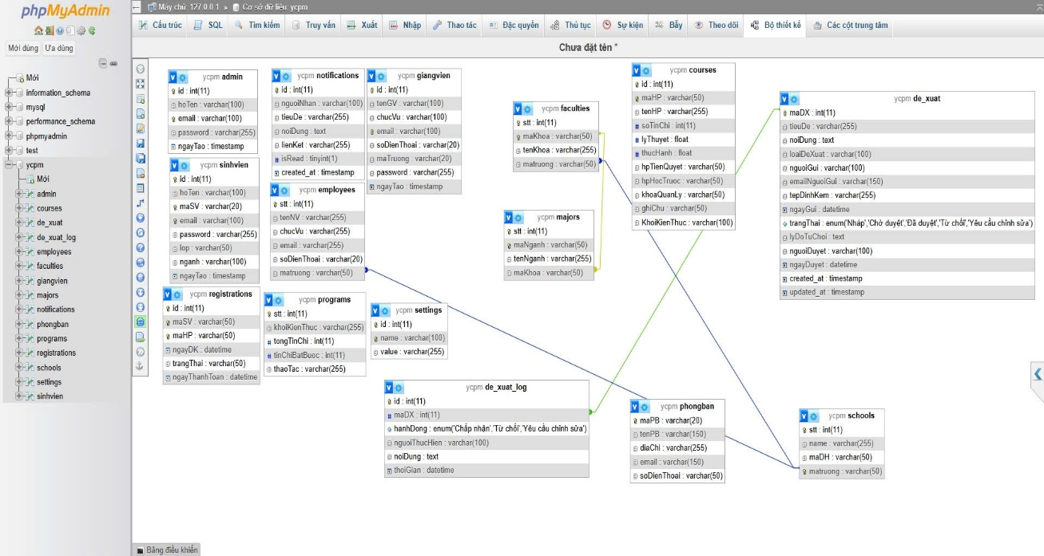

QUALITY ATTRIBUTES (NON-FUNCTIONAL REQUIREMENTS)
This section describes the non-functional requirements (NFRs) of the system, which are the quality attributes that the software must have. These requirements are critical to ensure that the system not only performs the required functions correctly, but also operates efficiently, safely, and meets the expectations of users and the organization.

Availability
The system should be easy to learn, easy to use, efficient, and user-friendly to optimize the experience and minimize errors.
- Easy to learn: New users, especially students and lecturers, can familiarize themselves with and use the basic functions of the system (e.g., looking up e-mails, viewing tuition fees) without in-depth guidance, within a maximum of 30 minutes.
- Efficiency: Experienced users can perform routine tasks quickly and efficiently (e.g., create/edit a module/block of knowledge in less than 2 minutes).
- User-friendly: The user interface should be intuitive, consistent in terms of layout, colors, and icons throughout the system.
- Error resistance: The system must have clear, easy-to-understand error messages and suggest corrective actions when users enter incorrect data or perform invalid operations.
- Language support: The system must fully support the Vietnamese language for all interfaces and content.
- Adaptability: The user interface must be designed to be responsive, ensuring that it displays and works well on different types of devices (desktops, tablets, smartphones) and popular web browsers.

Performance
The system must operate quickly and efficiently, meeting the requirements for processing speed and load capacity.
- . Response Time:
- Information lookup and display operations (e.g., e-commerce data, tuition fee lookup, user list) must have a response time of no more than 3 seconds under normal load conditions (less than 500 concurrent users).
- Data updates (e.g. adding/editing modules, updating user information) must have a response time of no more than 5 seconds.
- Scalability: The system must be able to support at least 1,000 concurrent users and process a minimum of 5,000 transactions per hour during peak hours without significant performance degradation.
- Storage capacity: The system must be able to store data for at least 5 years of continuous operation (estimated X TB of data) and be easily scalable as needed.
- Availability: The system must operate stably 24/7, with a maximum downtime of no more than 4 hours/month (guaranteed 99.45% uptime). Planned downtime (maintenance) must be communicated in advance.

Safety and security
The system must be protected from external and internal threats, ensuring the security and integrity of the data.
- User Authentication:
- The system must require user authentication with a username and password when accessing functions that require permissions.
- Passwords must be encrypted and stored securely in the database.
- Support secure password reset mechanism (e.g. via email/OTP).
- Authorization - RBAC:
- The system must implement strict role-based access control (RBAC), ensuring users can only access and perform functions that are appropriate for their roles and permissions.
- The permission model must be clearly defined and configurable by the Admin.
- Data Protection:
- All sensitive data (personal information, financial information) must be encrypted when transmitted over the network (using HTTPS/SSL/TLS).
- The data in the database must be protected from unauthorized access.
- Anti-attack: The system must have measures to prevent common web security vulnerabilities such as SQL Injection, Cross-Site Scripting (XSS), Cross-Site Request Forgery (CSRF).
- Session Control: User sessions must be securely managed, including automatically expiring sessions after a period of inactivity.
- Audit Log: Every important user action (login/logout, adding/editing/deleting data, changing permissions) must be recorded in the audit log with detailed information (who did it, when, action, who was affected) for audit and tracing purposes.
- Payment Standards: The online tuition payment function must comply with the security standards of the payment industry (e.g., PCI DSS if card information is handled directly) and the regulations of the integrated payment gateway.

Safety
The requirements are intended to minimize the risk of harm to data or system operations in the event of a failure.
- Data recovery: The system must have a mechanism for automatic data backup periodically (e.g., daily, weekly) and the ability to restore data within X hours (e.g., 24 hours) when a serious data loss incident occurs.
- System error handling: When the system encounters a critical error, there must be a mechanism to display error messages friendly to the end user and record the error details in the log so that the technical team can fix them. The system must not lose data or cause other negative consequences.
- Data integrity: The system must maintain the integrity and consistency of the data even if hardware or software failures occur (e.g., using database transactions).

LOCALIZATION AND INTERNATIONALIZATION REQUIREMENTS
This section specifies requirements related to language support and other regional conventions, ensuring that the system can operate efficiently and user-friendly in various cultural and geographical contexts.
1. Language and Cultural SupportThe system must be designed to easily adapt to different languages and cultural conventions. Initially, the system will focus on fully supporting Vietnamese.
- Display language: The system must fully support the Vietnamese language for all user interfaces, notifications, help content, and related documentation.
- Regional format: The system must display the date, time, numerical format (e.g., thousands separator, decimal point) and currency unit (VND) according to the conventions common in Vietnam.
- Language scalability: The system must be built on an international standard platform (e.g., using Unicode/UTF-8 encoding) to easily add other language packages (such as English) in the future without major changes to the source code. All text strings on the interface must be separated from the source code to facilitate translation.
2. Time processing and data arrangementThe system needs to manage time and data sorting operations flexibly, in accordance with different standards.
- Time zone: The system must be able to store time according to international standards (UTC) and display it in the user's local time zone or according to the school's configuration.
- Sorting and searching: The system must support sorting and searching text data (e.g., student names, module names) in the correct alphabetical order and Vietnamese language context (with accents supported) correctly.
3. Compliance with technical standardsThe system must comply with international technical standards to ensure compatibility and scalability.
- Character encoding: The system must use the Unicode character encoding standard (UTF-8) for all text data stored and displayed, ensuring support for a wide range of character sets.
- Interface adaptability: UI components must be designed so that they can automatically adjust their size and layout to different reading directions (e.g., from left to right) if the system is expanded to support languages with other reading directions in the future.

OTHER REQUIREMENTS
This section lists additional requirements that do not fall under the categories of functions or quality attributes detailed above, but are still important to the success, operation, and compliance of the system.
1. Compliance and regulatory requirementsThe system must comply with legal regulations and internal regulations related to the school's operation.
- Compliance with training regulations: The system must comply with the current regulations and regulations of the Ministry of Education and Training on the management of training programs, credits, learning results and graduation requirements.
- Personal and financial data protection: The system must comply with the legal regulations on the protection of users' personal data and the privacy policies of the organization. The function of calculating and paying tuition fees must comply with regulations on financial management, accounting and taxation.
2. Documentation and Support Requirements Clear documentation and support mechanisms are required to ensure users can use the system effectively and receive help when needed.
- Instructional documents: The system must have detailed and clear user manuals for each user (Students, Lecturers, Training Room Staff, Admin) in the form of text and/or video.
- Help system: The system should integrate an online help system or frequently asked questions (FAQ) so that users can find support information quickly.
- Support channels: There should be clear technical support channels for users (e.g., email, call center, ticketing system) to resolve issues that arise during use.
3. Project management and sustainability requirementsThese requirements relate to the management aspects of the project and the ability to maintain and develop the system in the long term.
- Change Management Process: There must be a clear process for managing change requests to the system after this specification document is approved, including impact assessment, approval, and implementation.
- Audit ability: The system must be able to generate audit reports on data changes and important user activities to serve inspection and monitoring.
- Sustainability and feasibility: The system must be designed with a clear architecture that is easy to maintain and expand to ensure long-term sustainable operation, minimizing maintenance and upgrade costs. The technologies used must be feasible, well-documented, and have a thriving community.

REFERENCES
[1] Refrence 1
[2] Refrence 2

APPENDIX (if applicable)

